1. Unwanted error message display while click the update button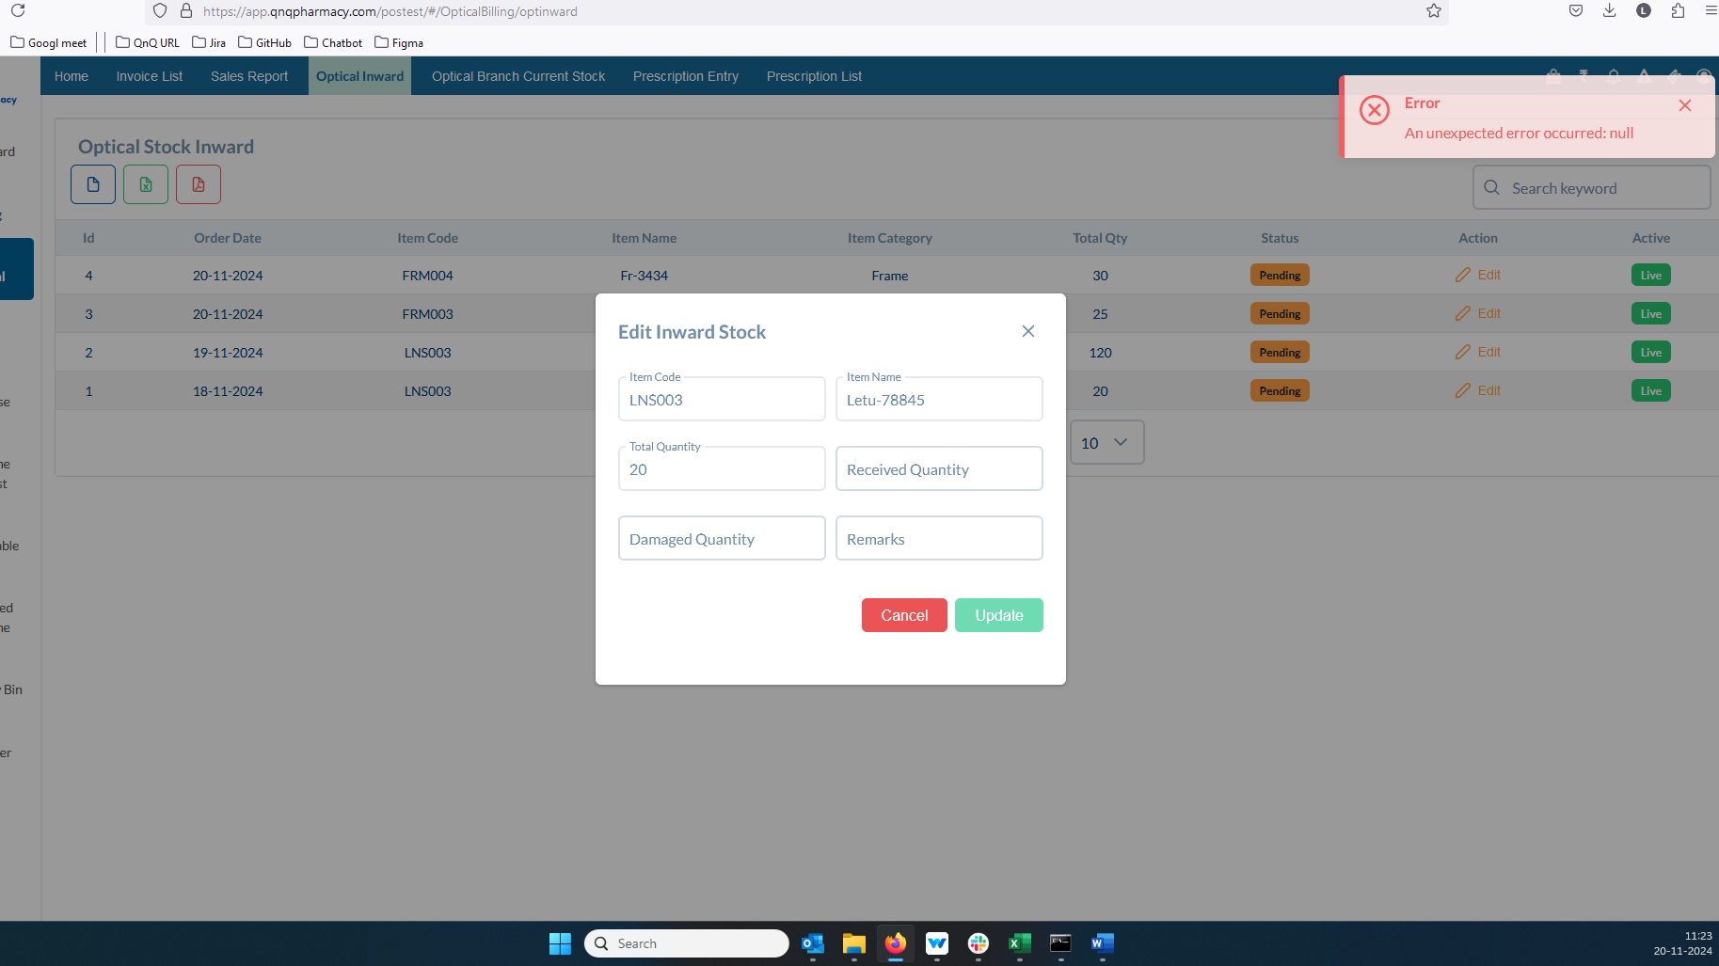//
2. Required error message not display while click the update button //
3. The Quantity field permits letters and special symbols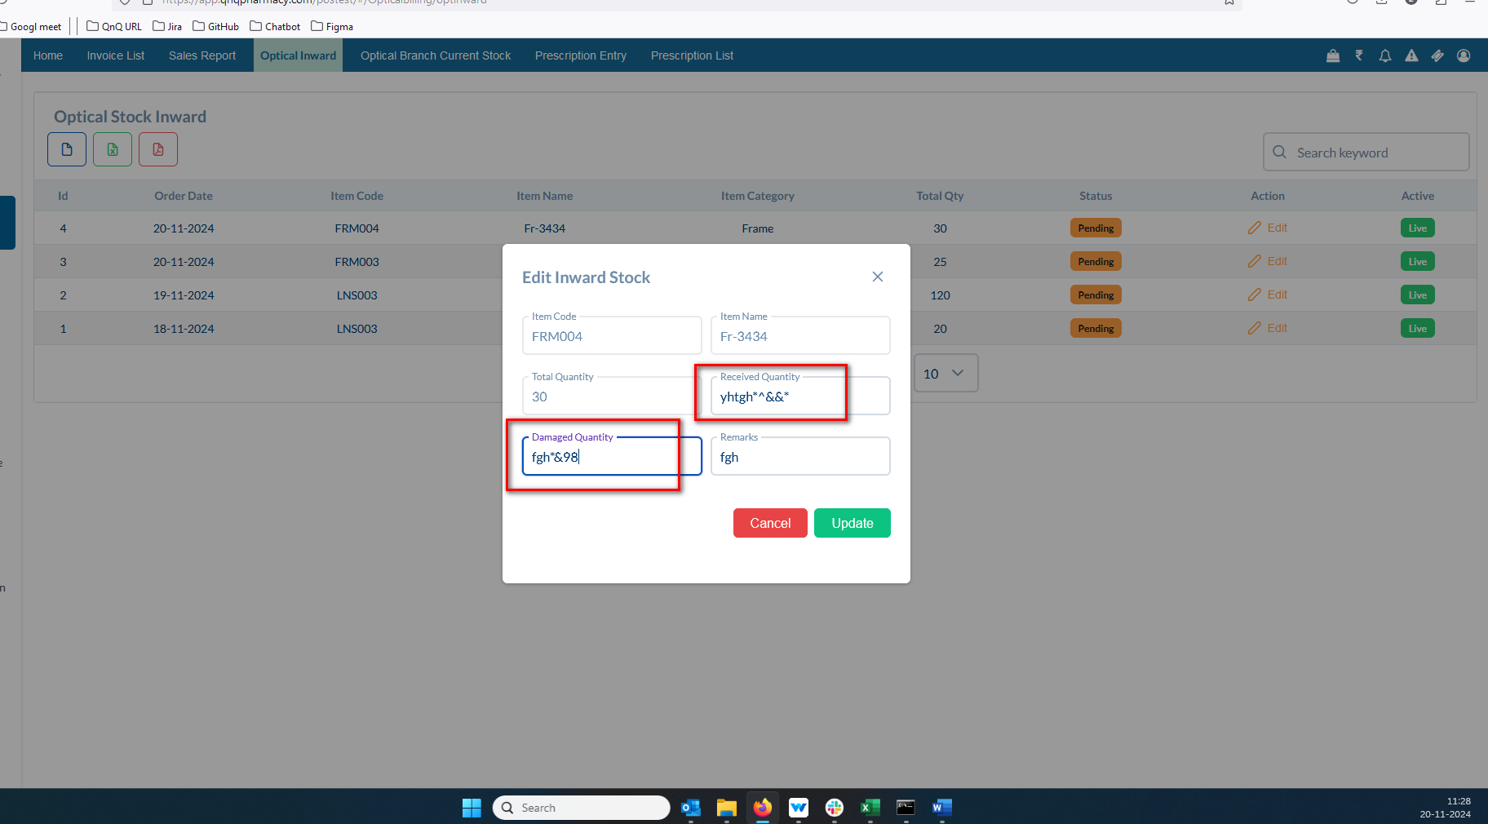//
4. Quantity fields allow more than 100 value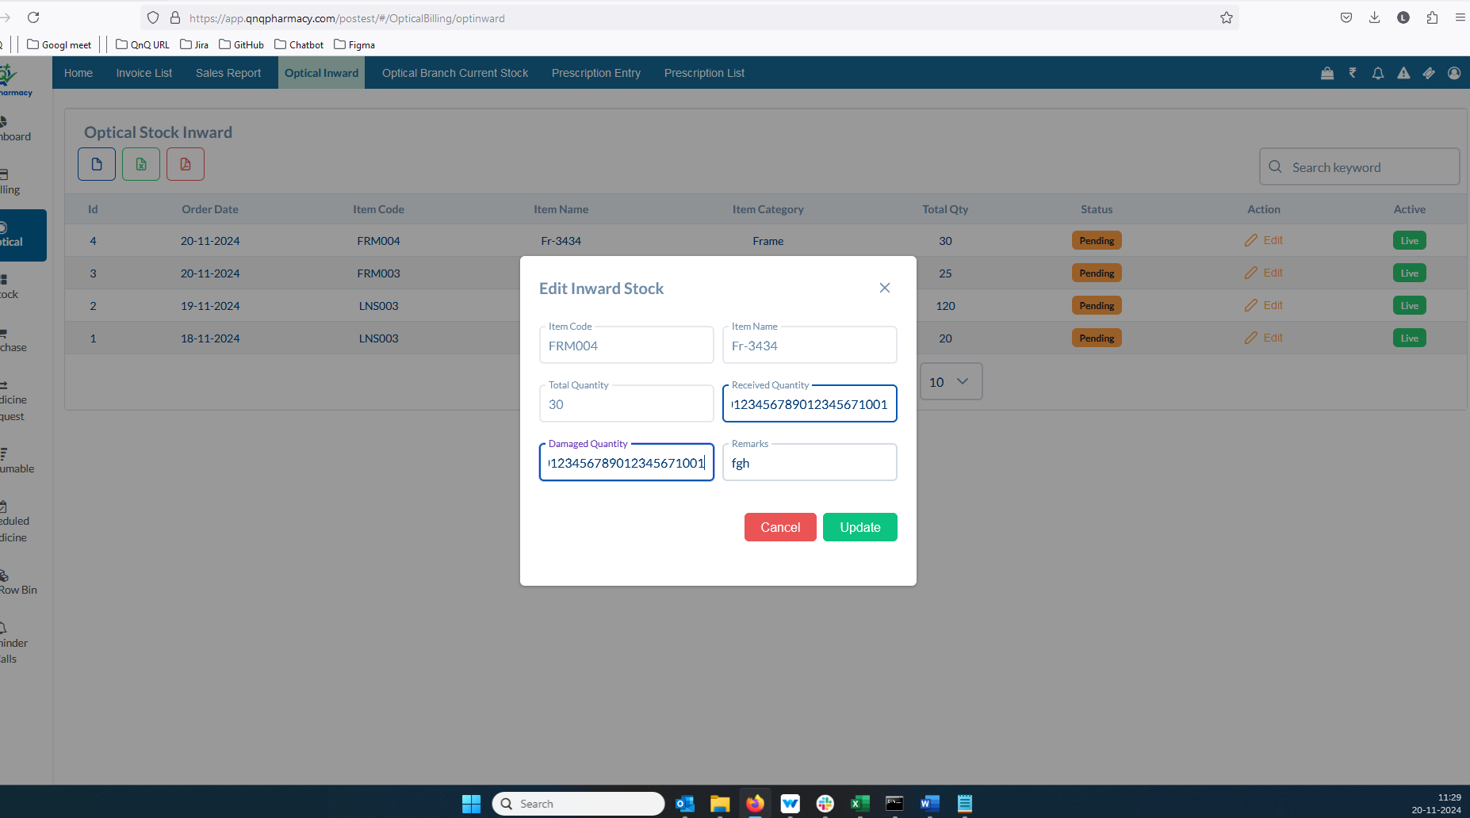//
5. Unwanted error message display while update the record with max value 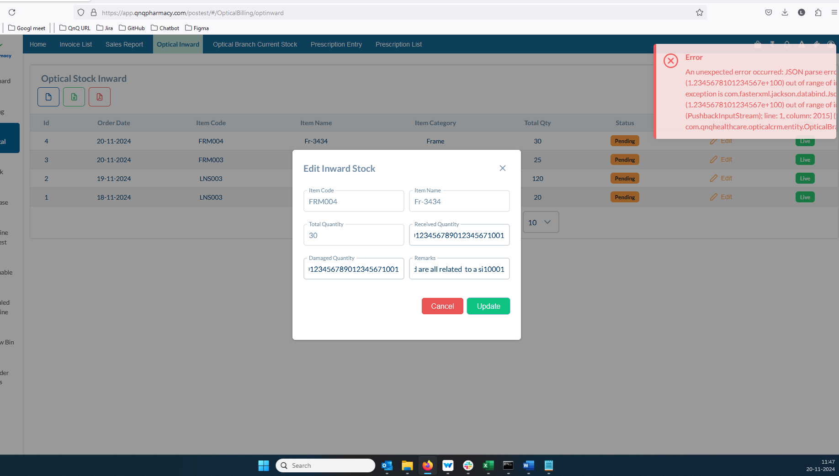 //
6. No error message appears in the system if the received quantity is greater than the total quantity 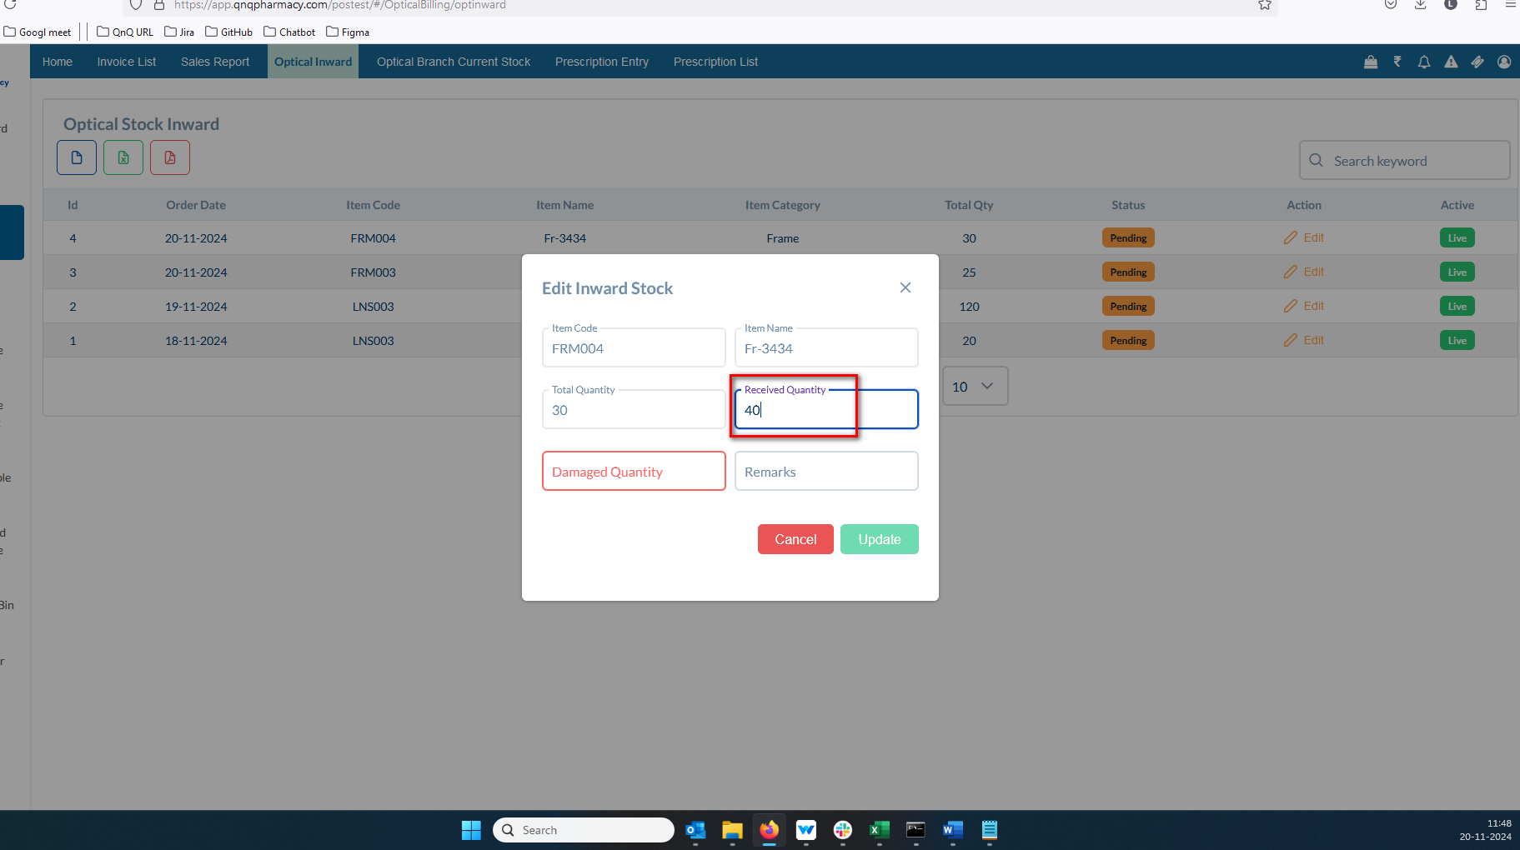 //
7. No error message appears in the system if the damaged quantity is greater than the total quantity 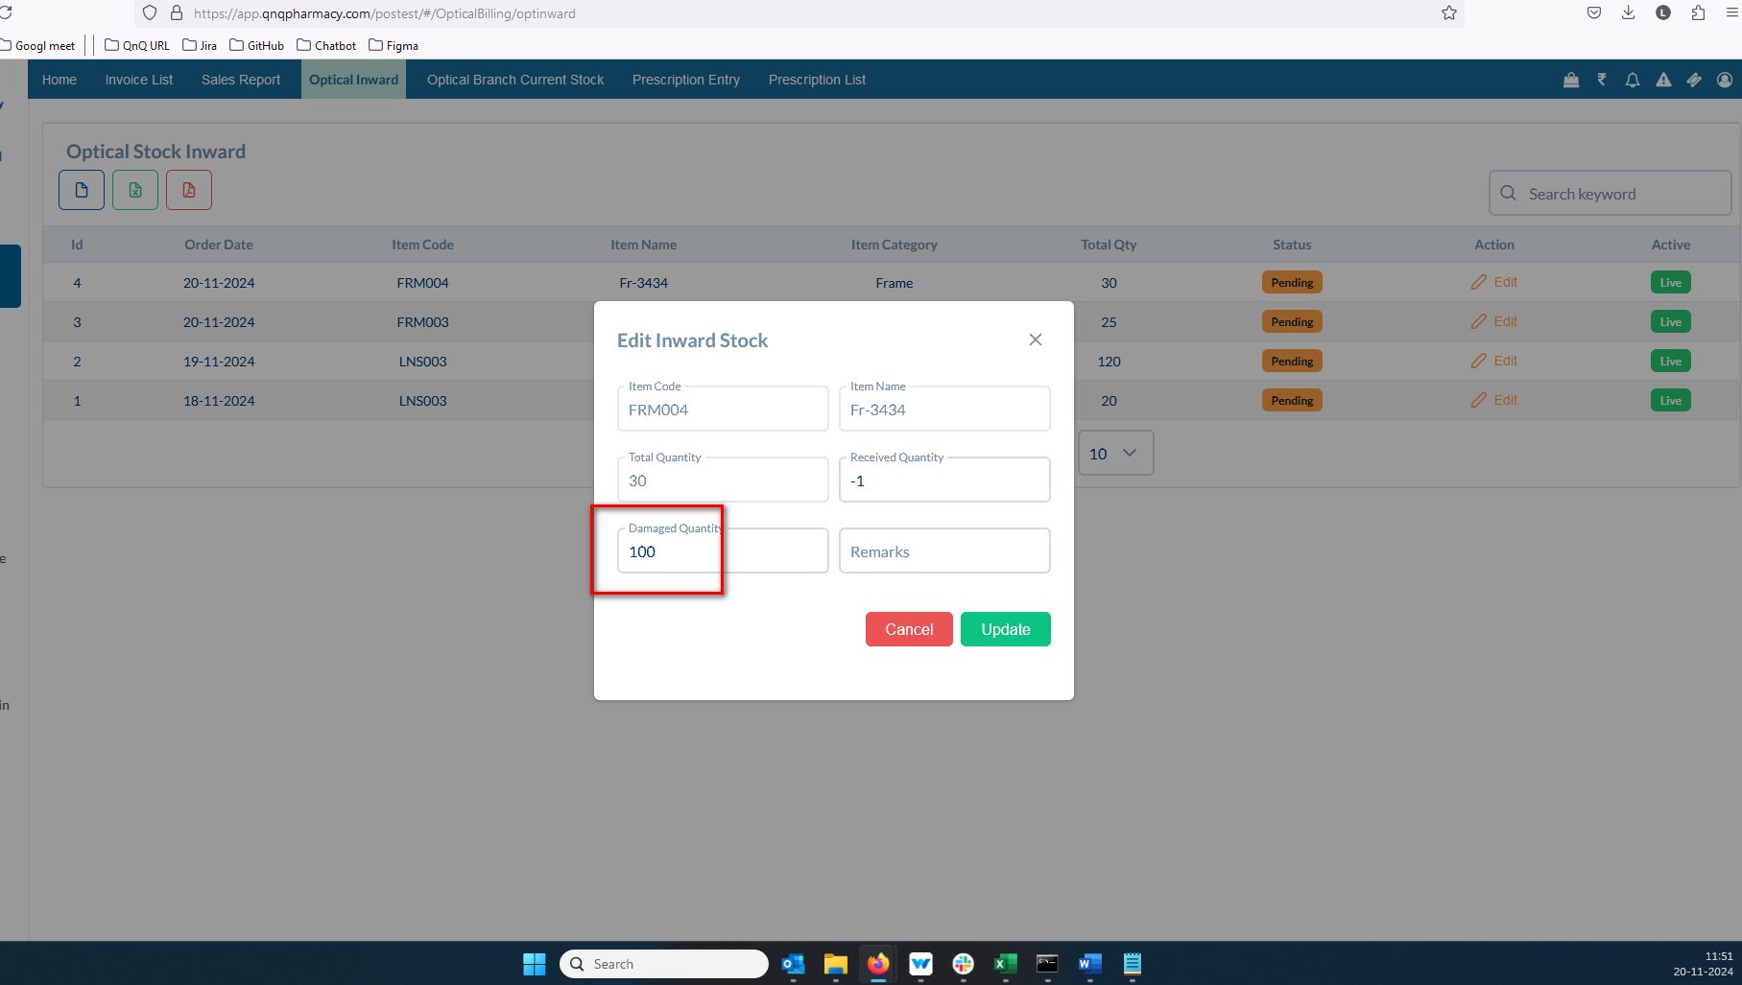 //
8. Pop up Title not display as Title header 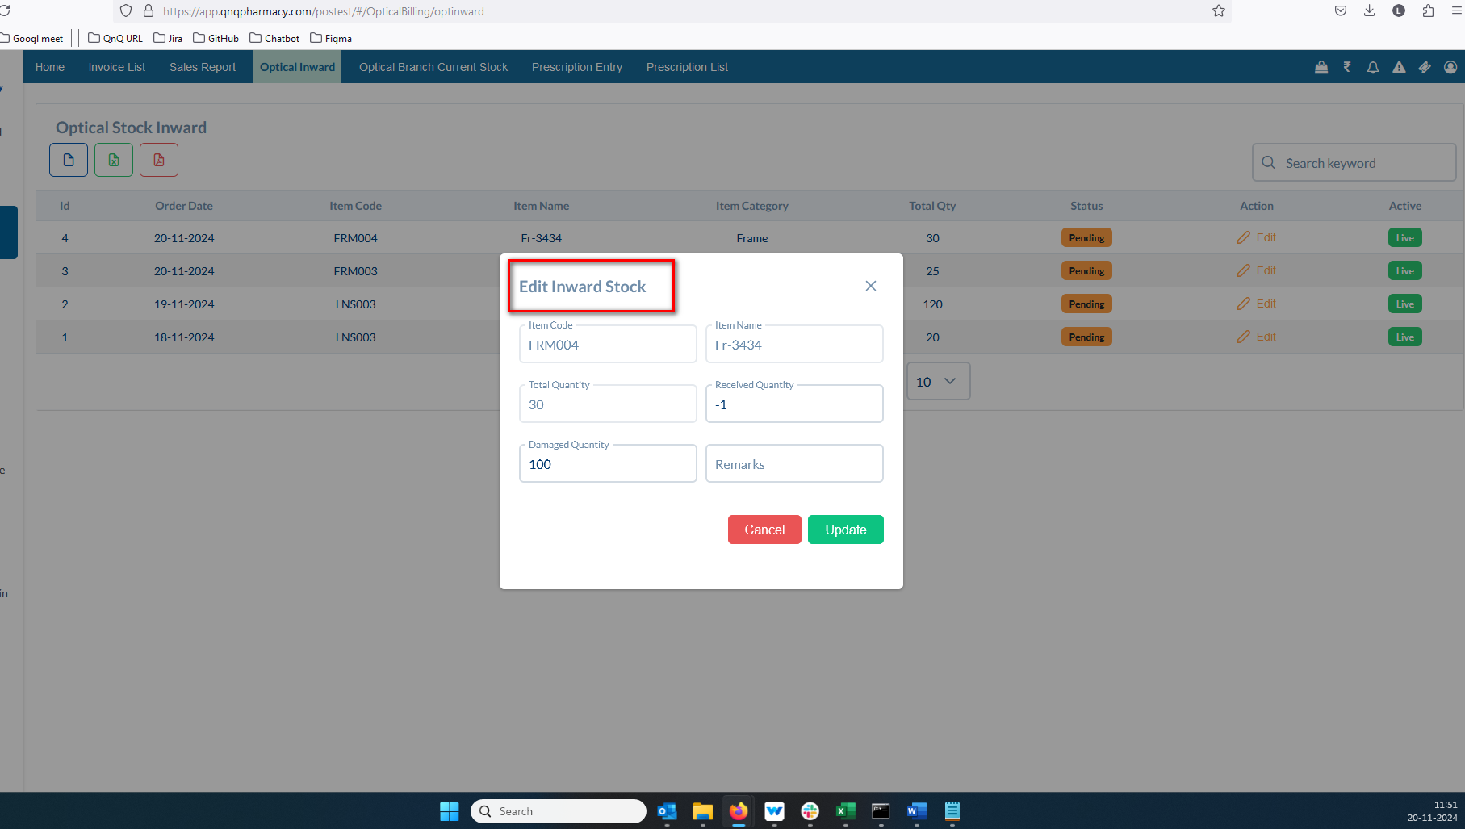 //
9. Tool tip not display for Close icon in pop up 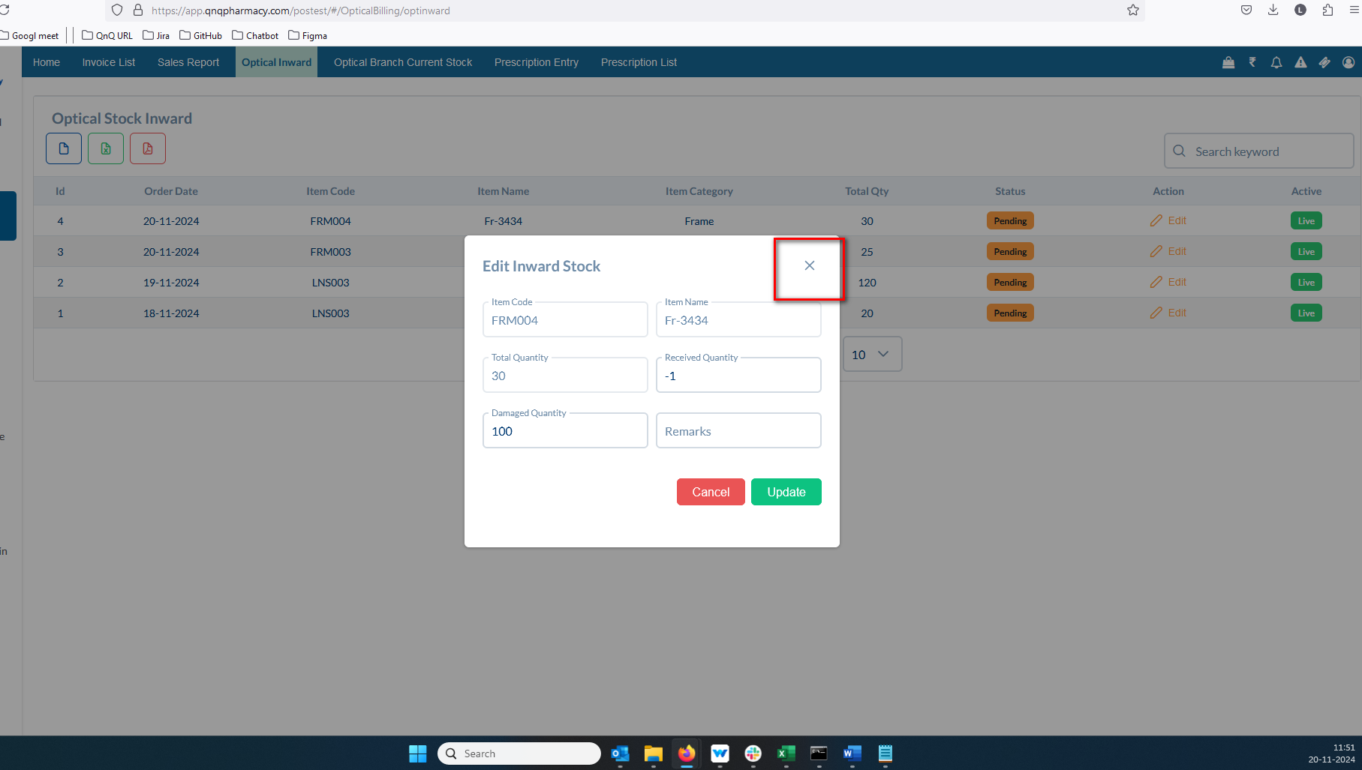 //
10. Error message display while click the update button 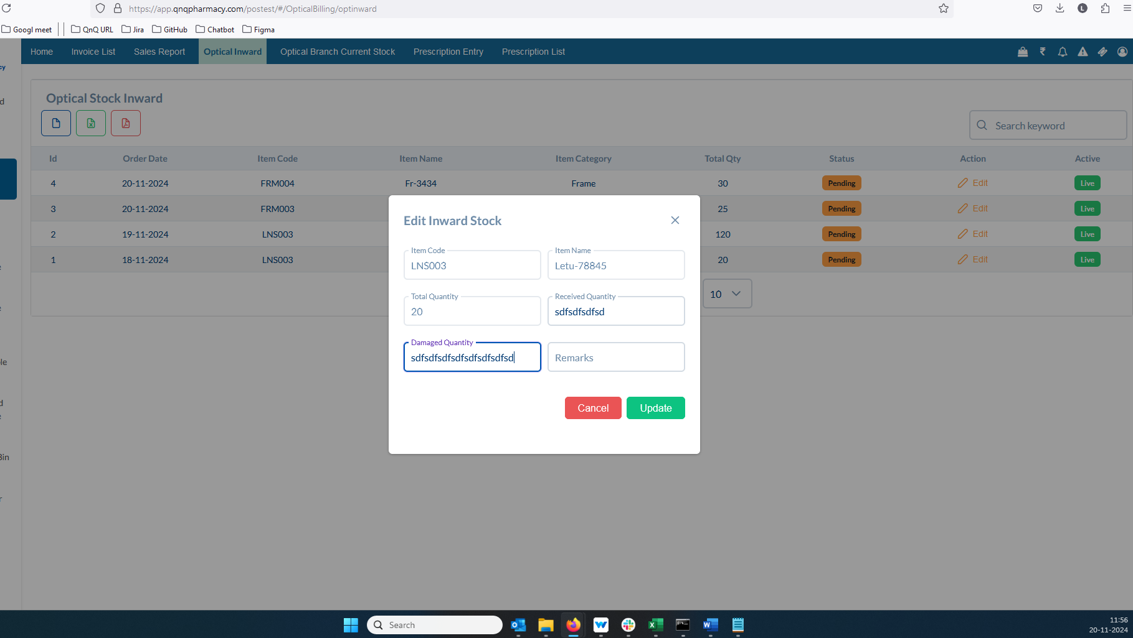 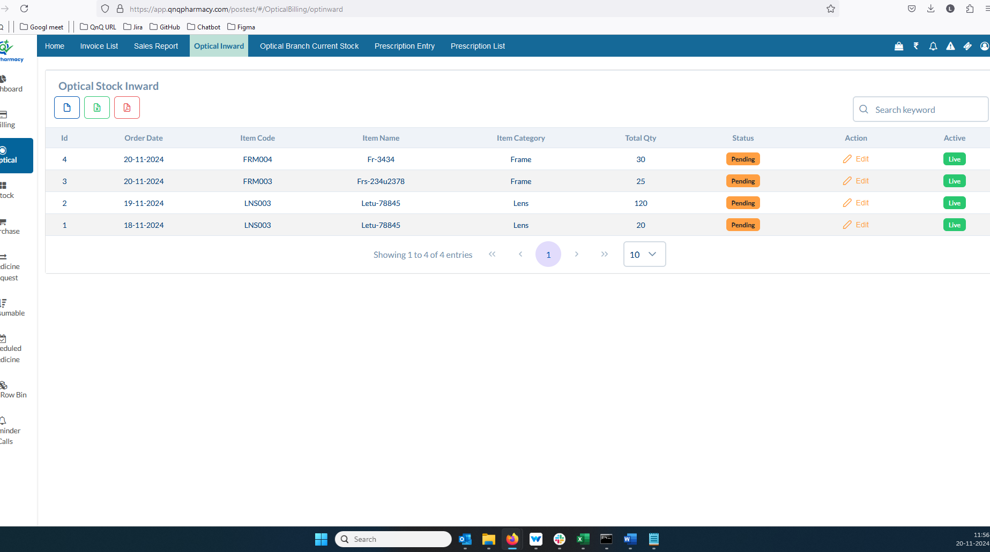 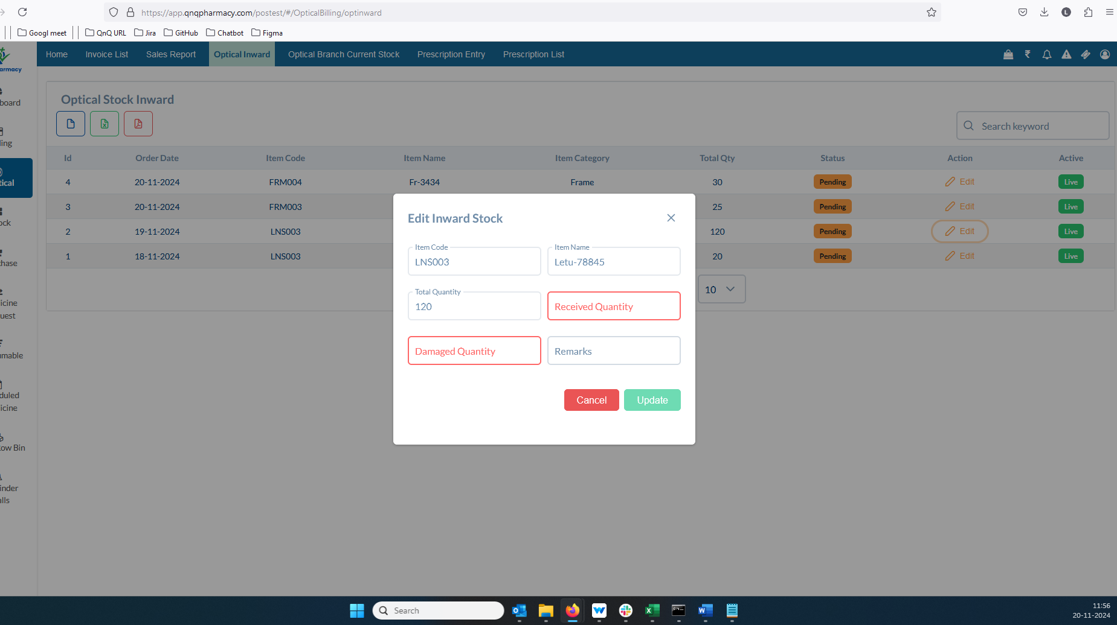 //
11. Button name not display as submit 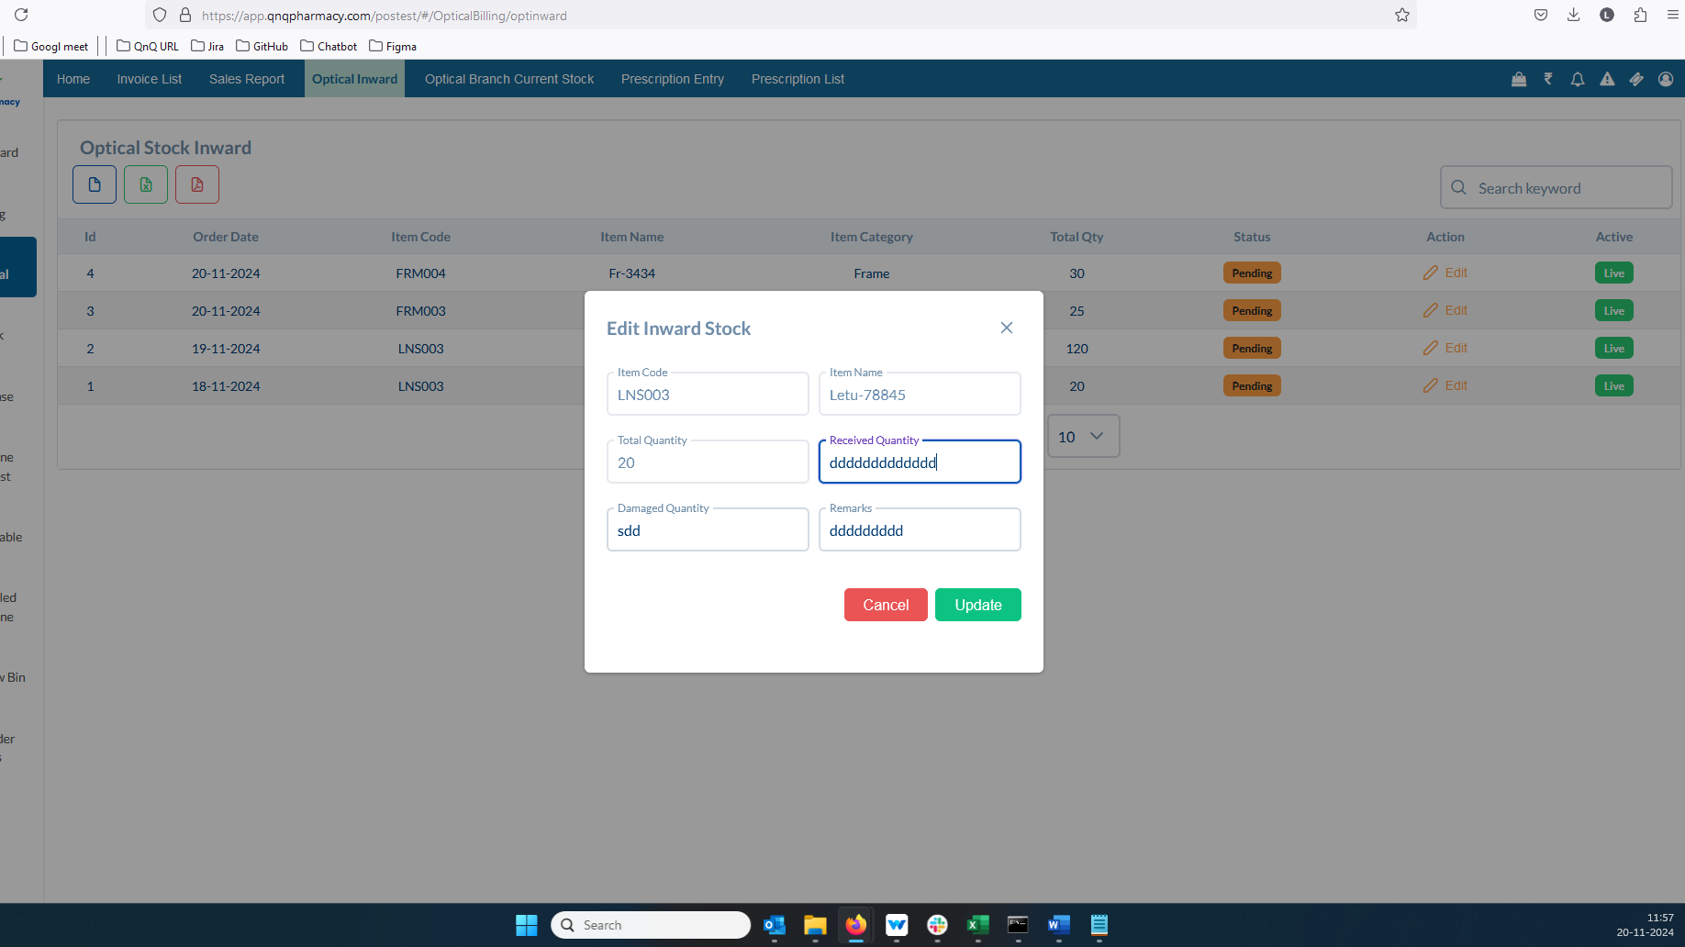 //
12. Confirmation message not display while click close button with the value 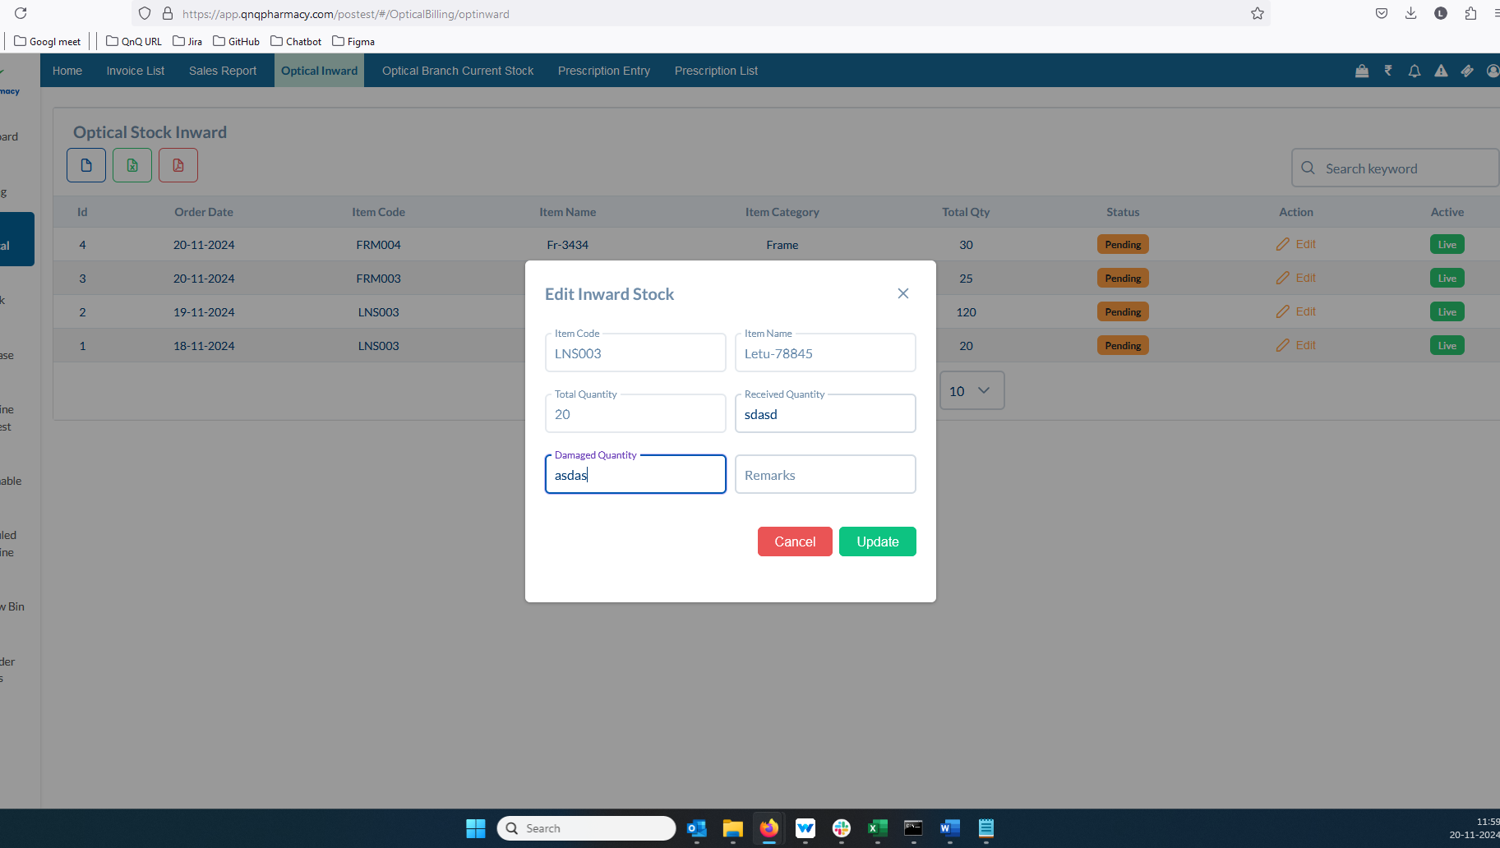 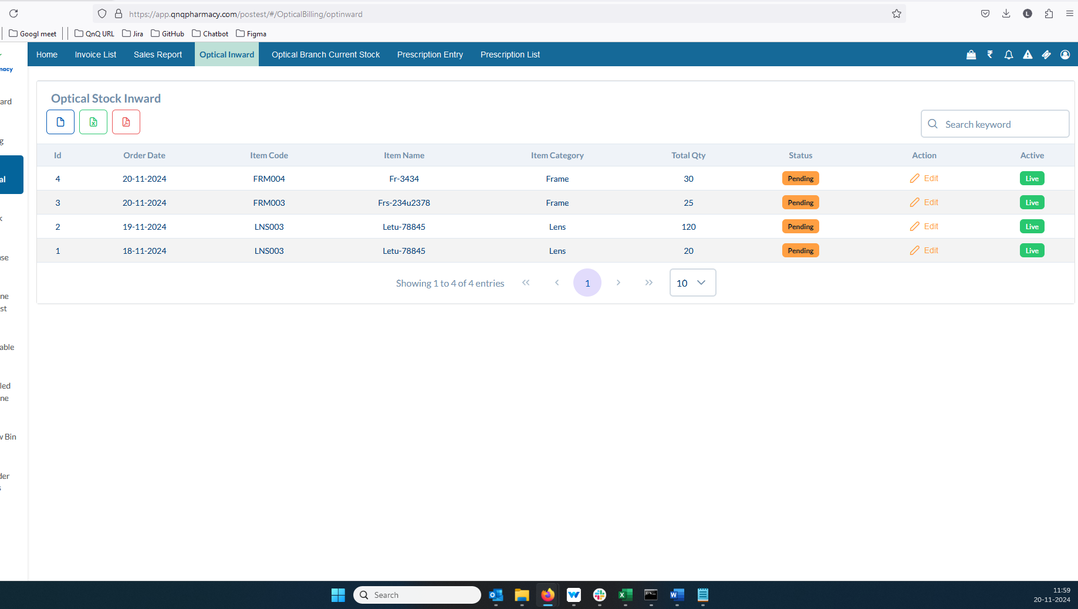 //
13. There is a mismatch between the screen title and the menu name 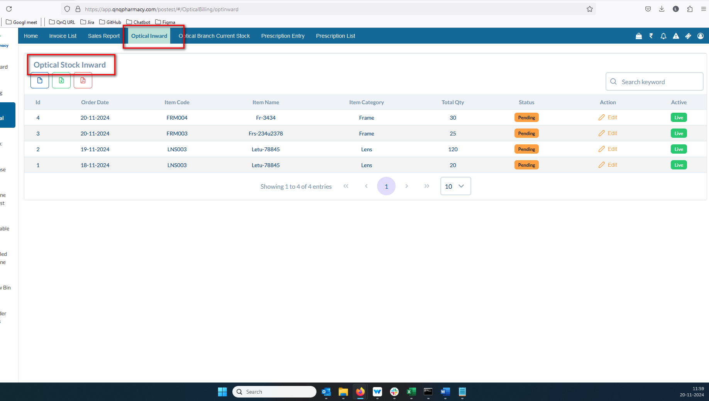 //
14. Sort icon not display in list column 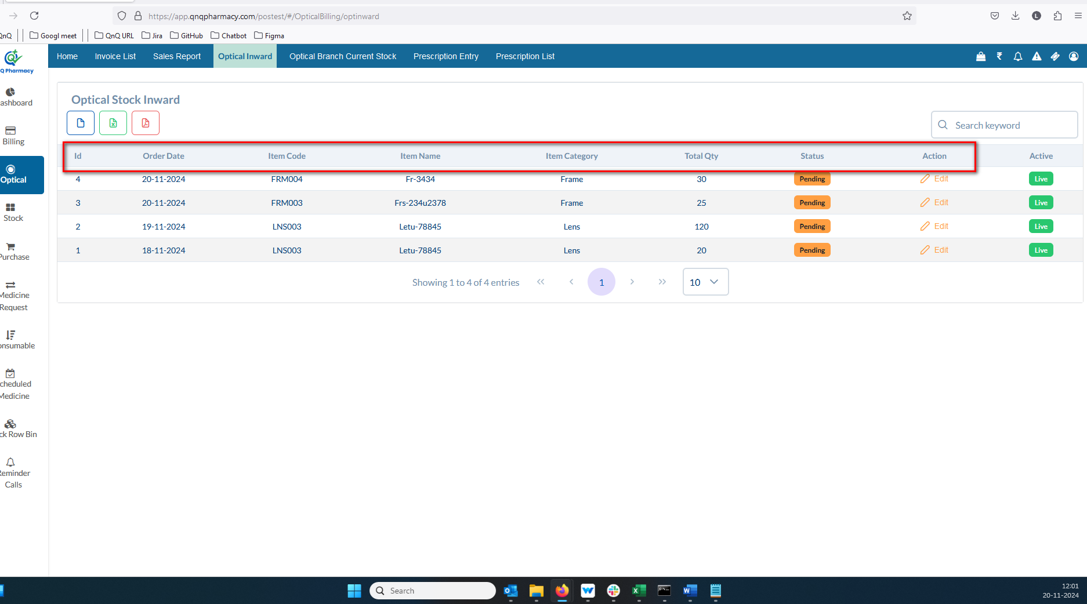 //
15. Unwanted colour display while click column header 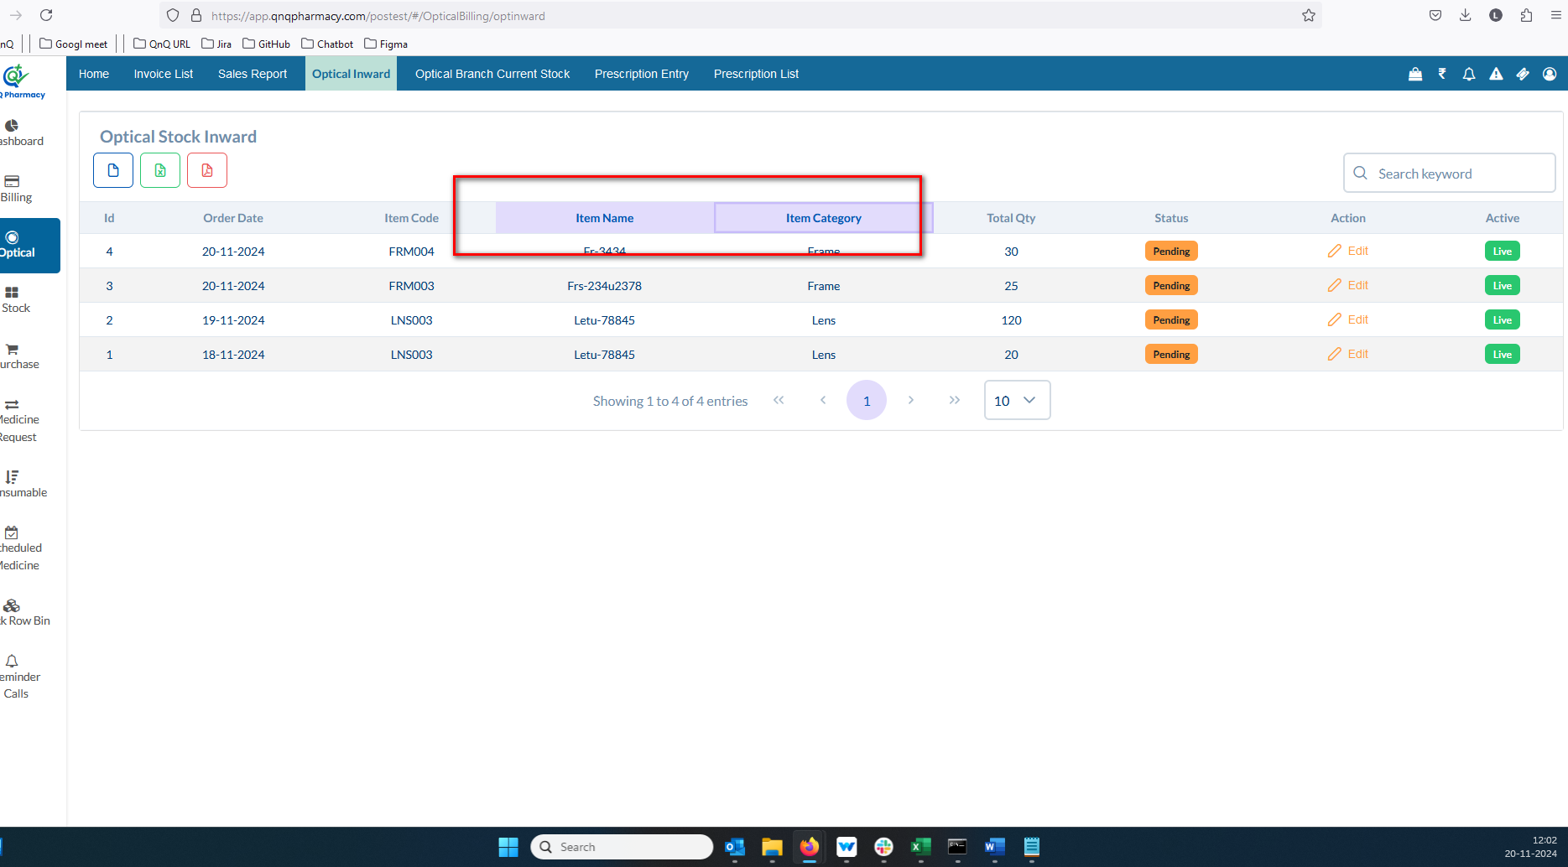 //
16. Mismatch column name display in list grid 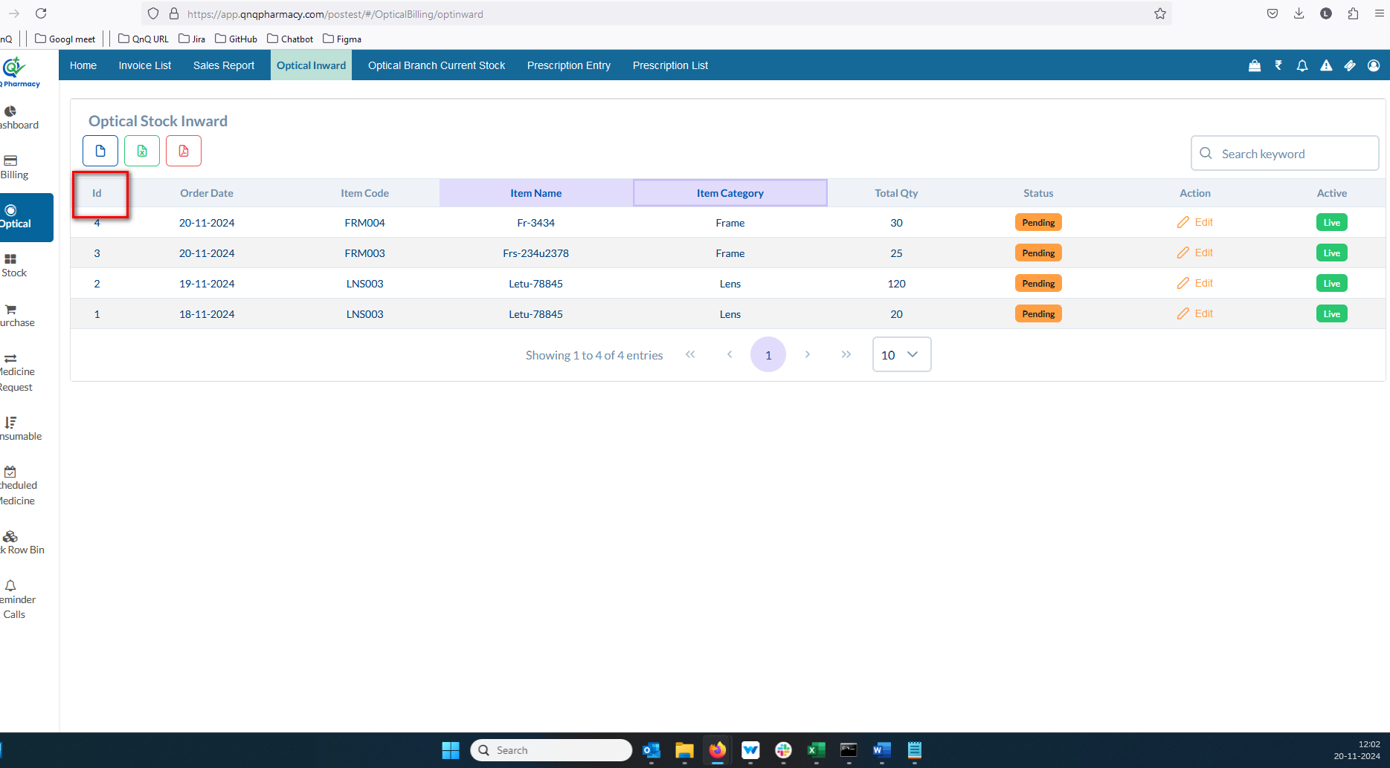 //
17. Unwanted column display in list grid 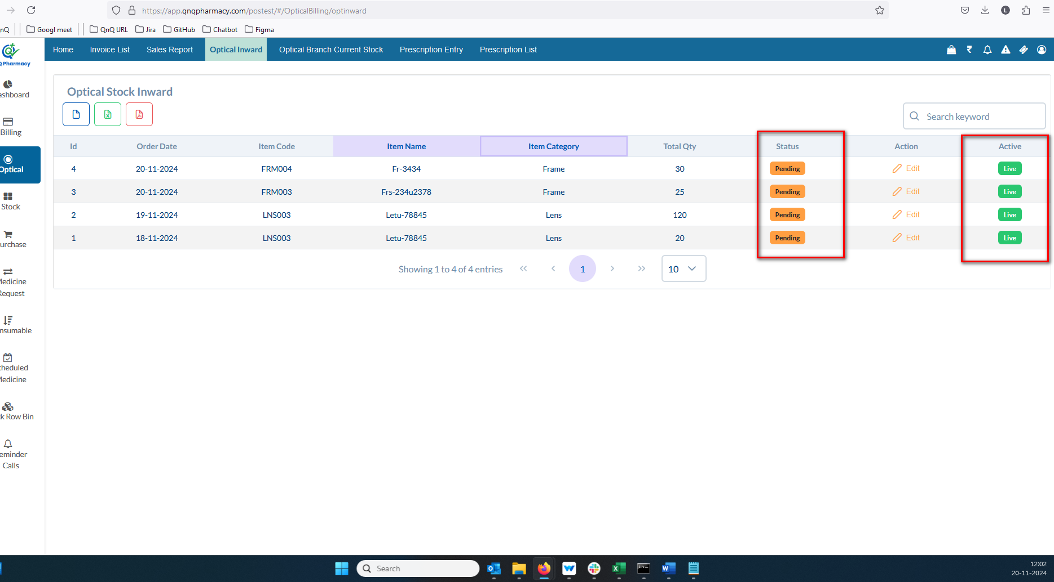 //
18. The pagination controls and count dropdown are positioned in the center of the page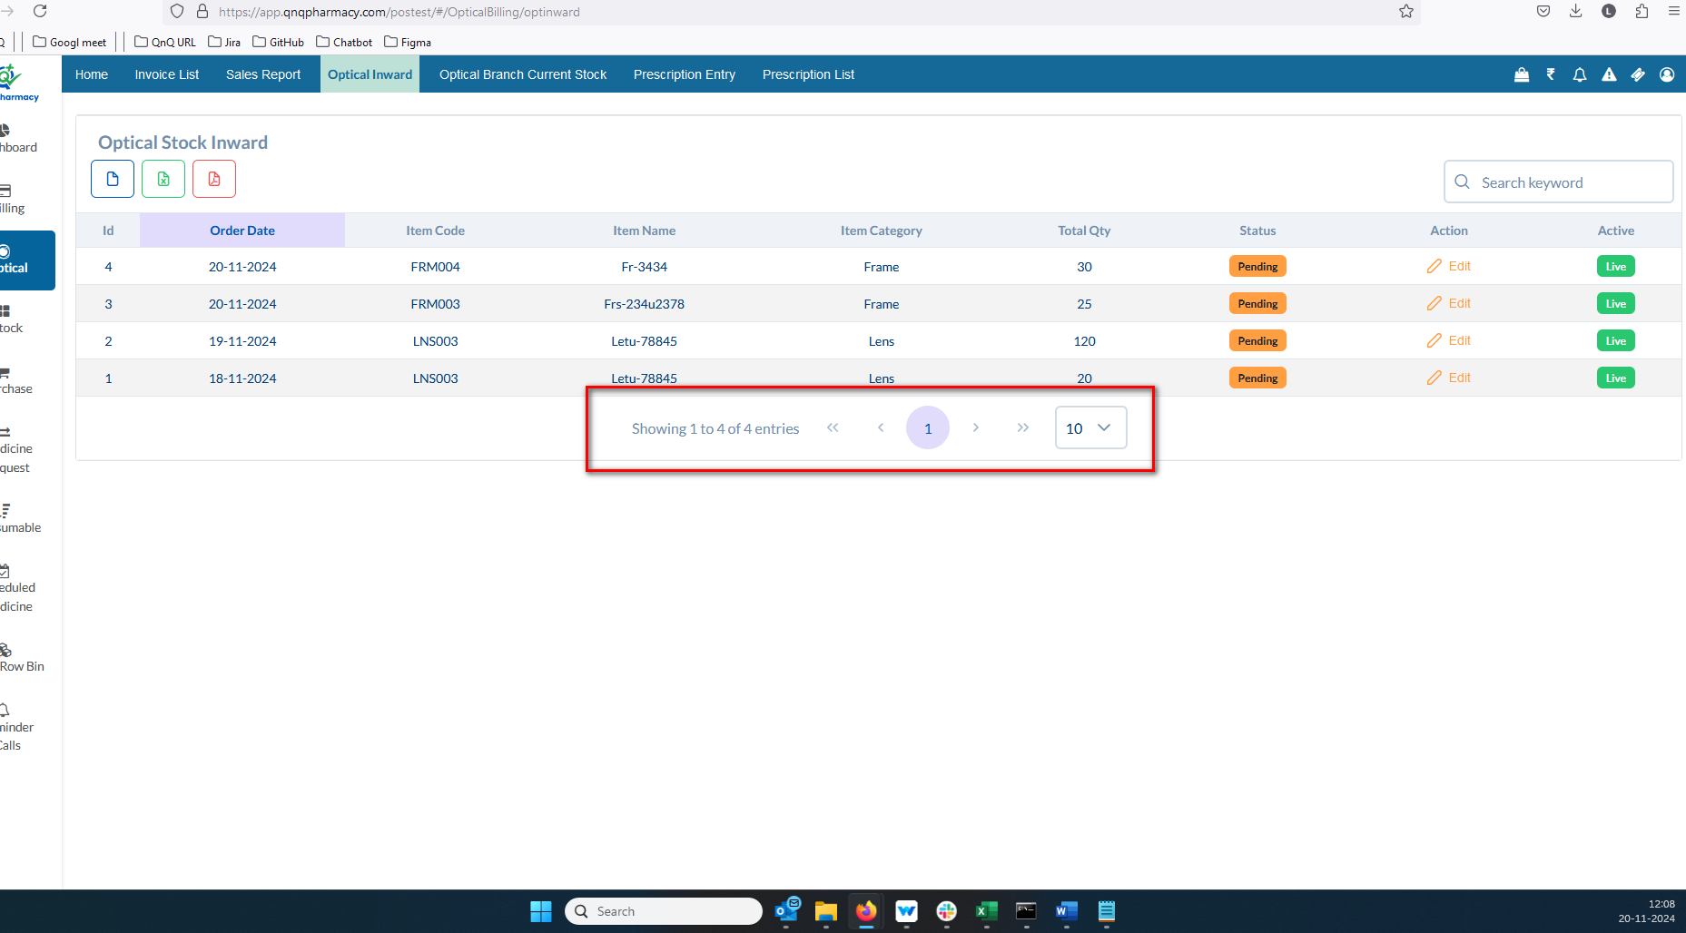 //
19. The sorting feature is not functioning for any column except S.No.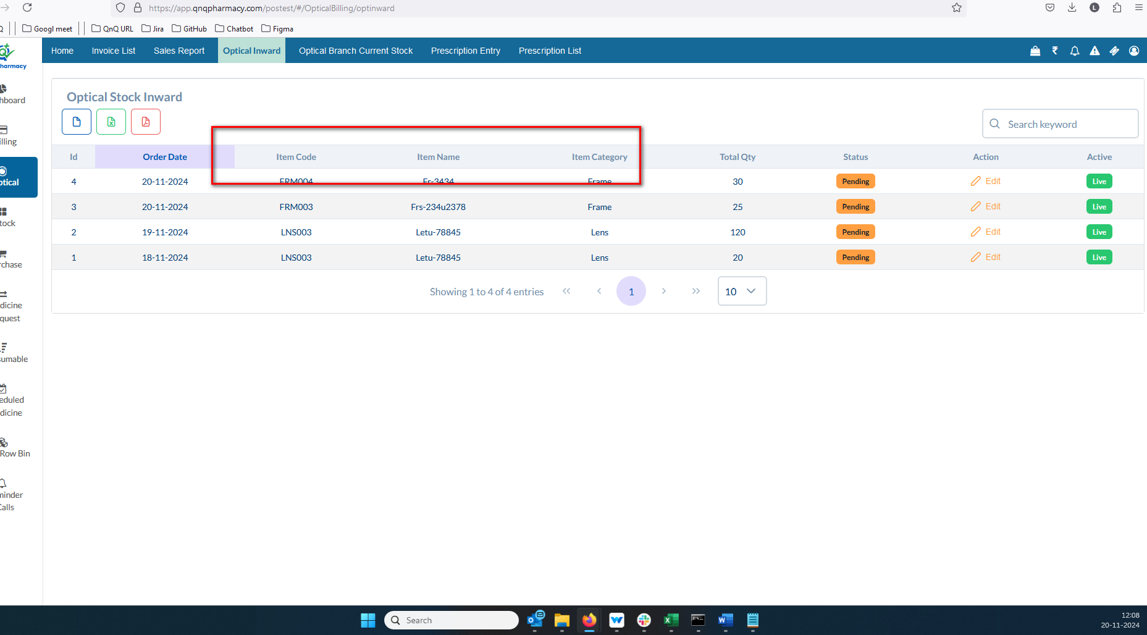 //
20. The search filter doesn't work in the list grid view 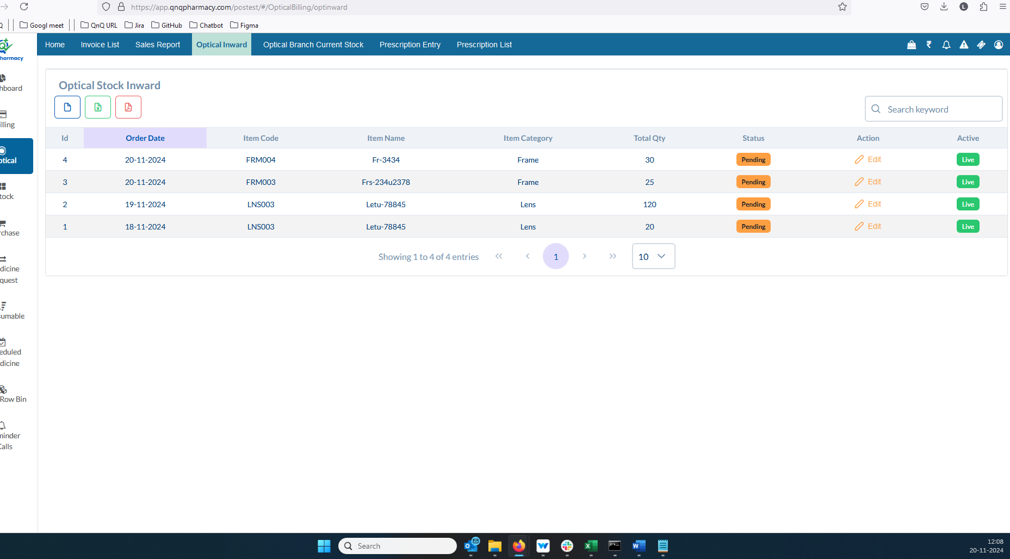 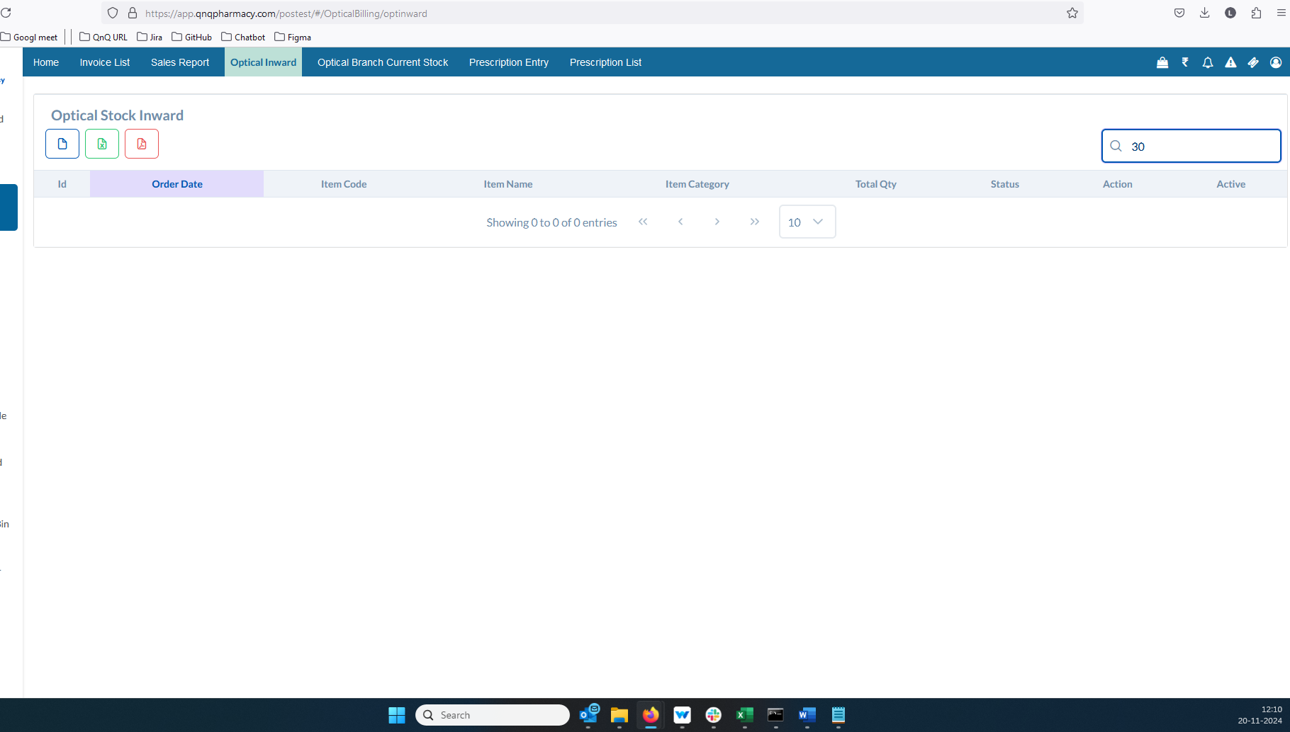 //
21. The Qty field in the list grid column header does not show the dot value 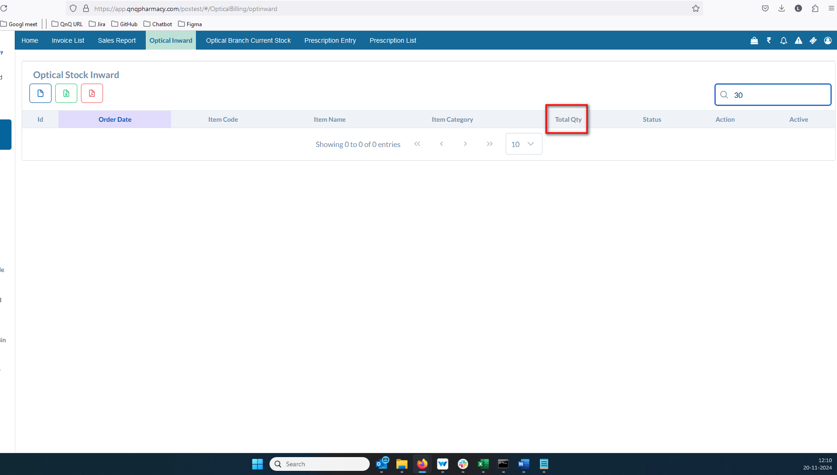 //
22. Mismatch column name display in order received date 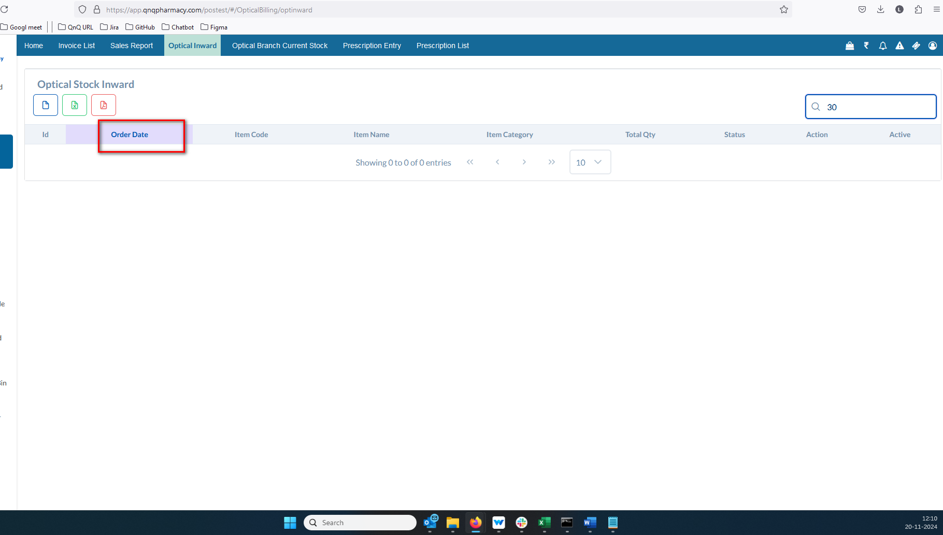 //
23. Duplicate records display in Inward list grid 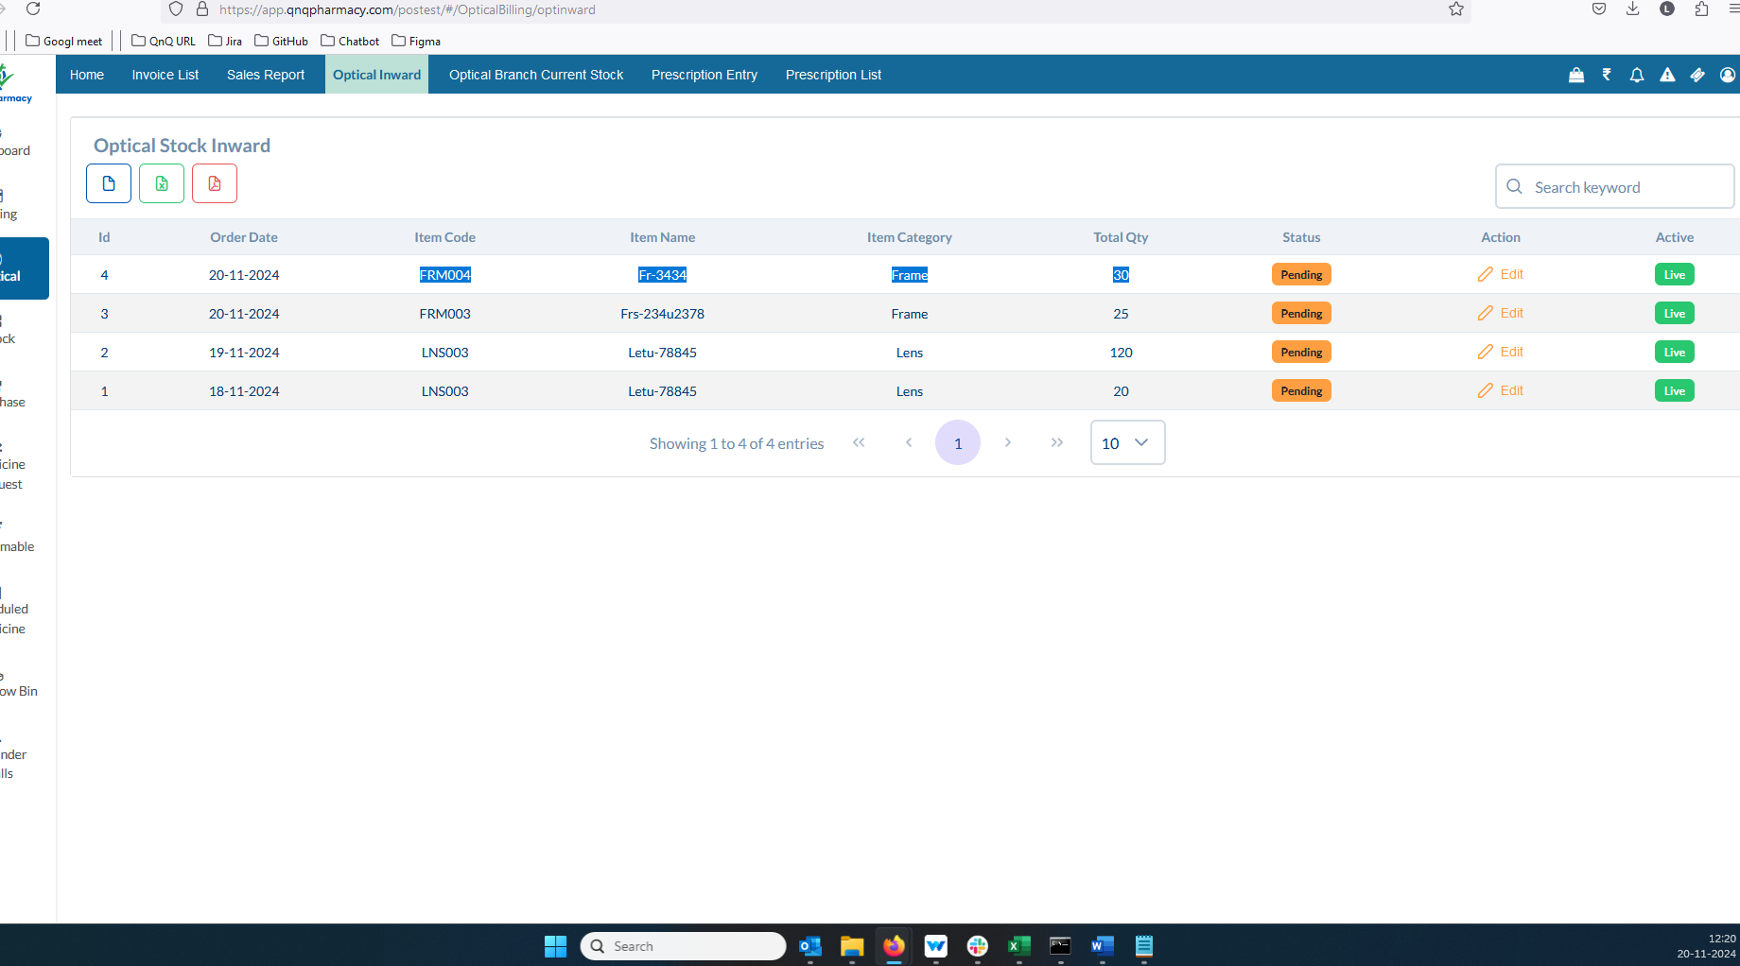 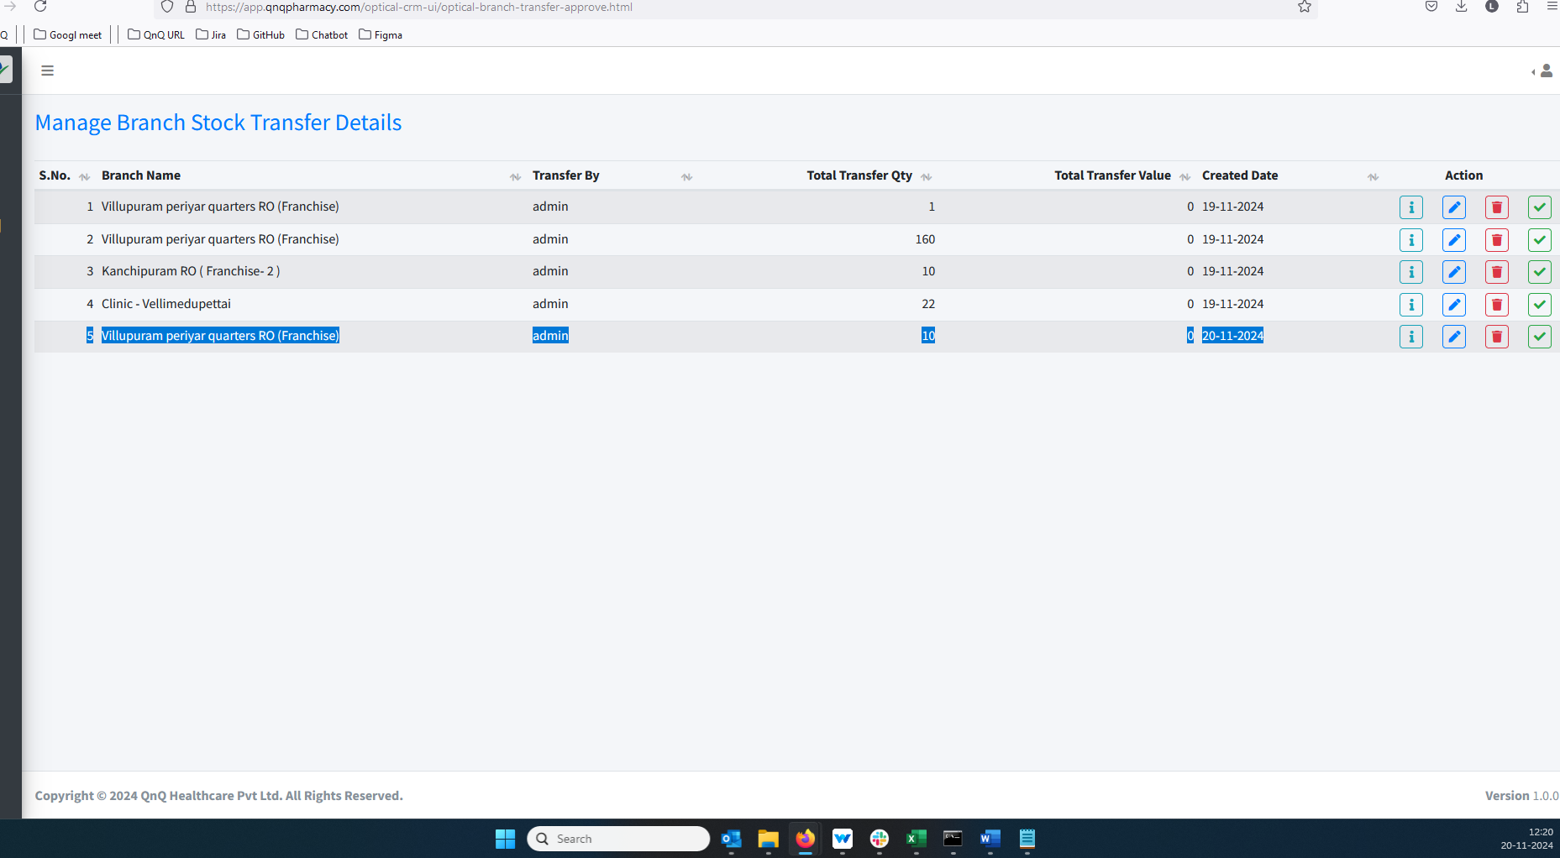 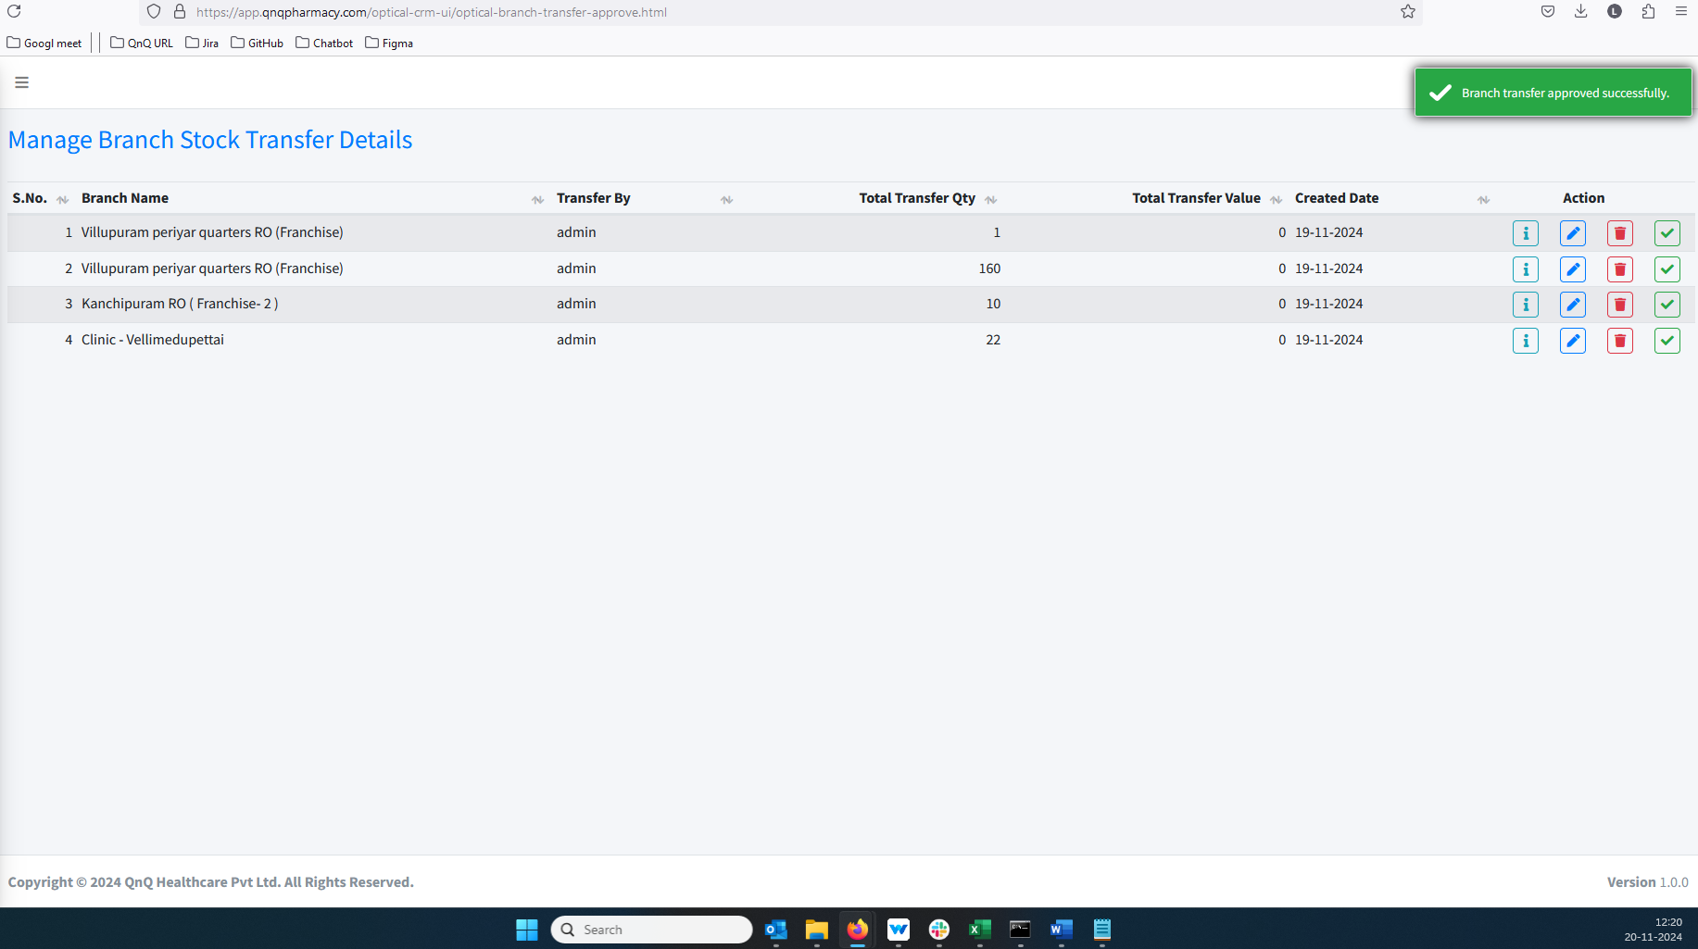 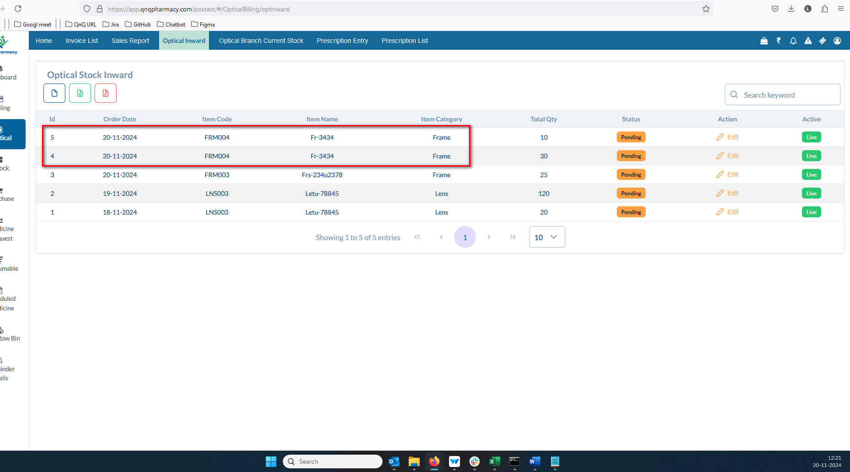 //
24. The column separation line/border is not visible in the Inward list grid 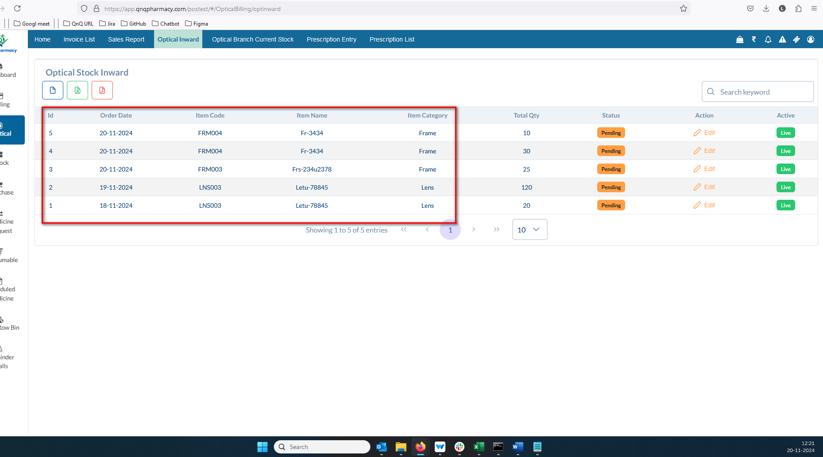 //
25. The list grid presents one type of data, while the downloaded document shows another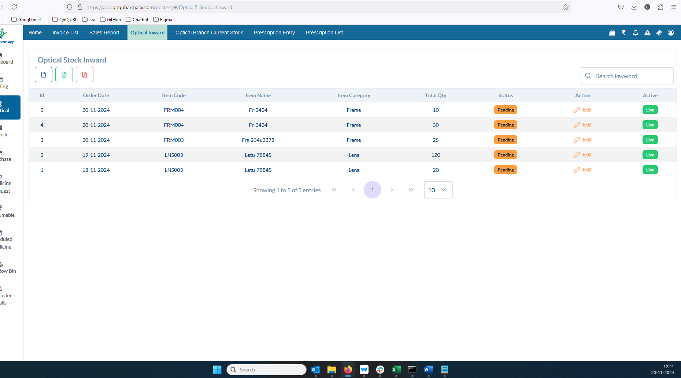 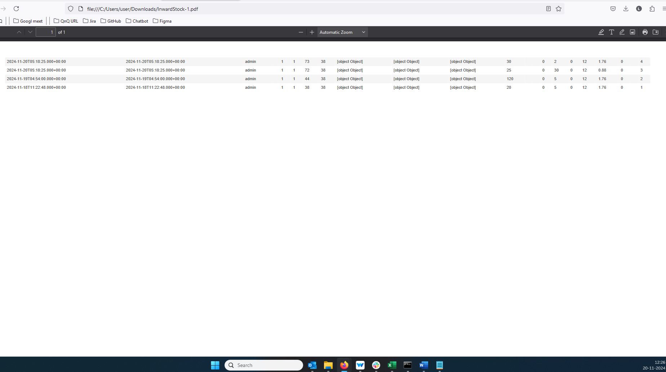//
26. Mismatch File name display in the CSV file 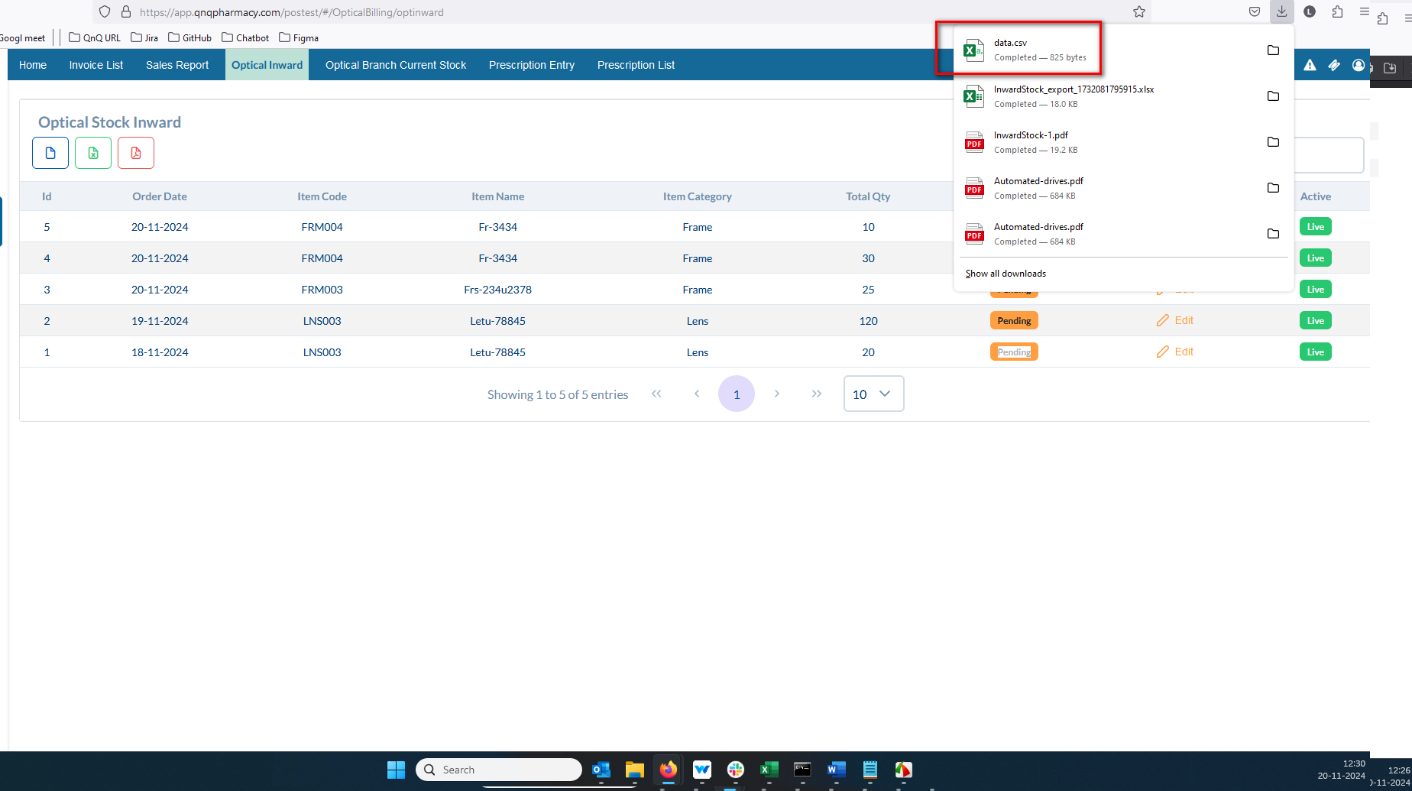//
27. Unwanted error message display while open the CSV file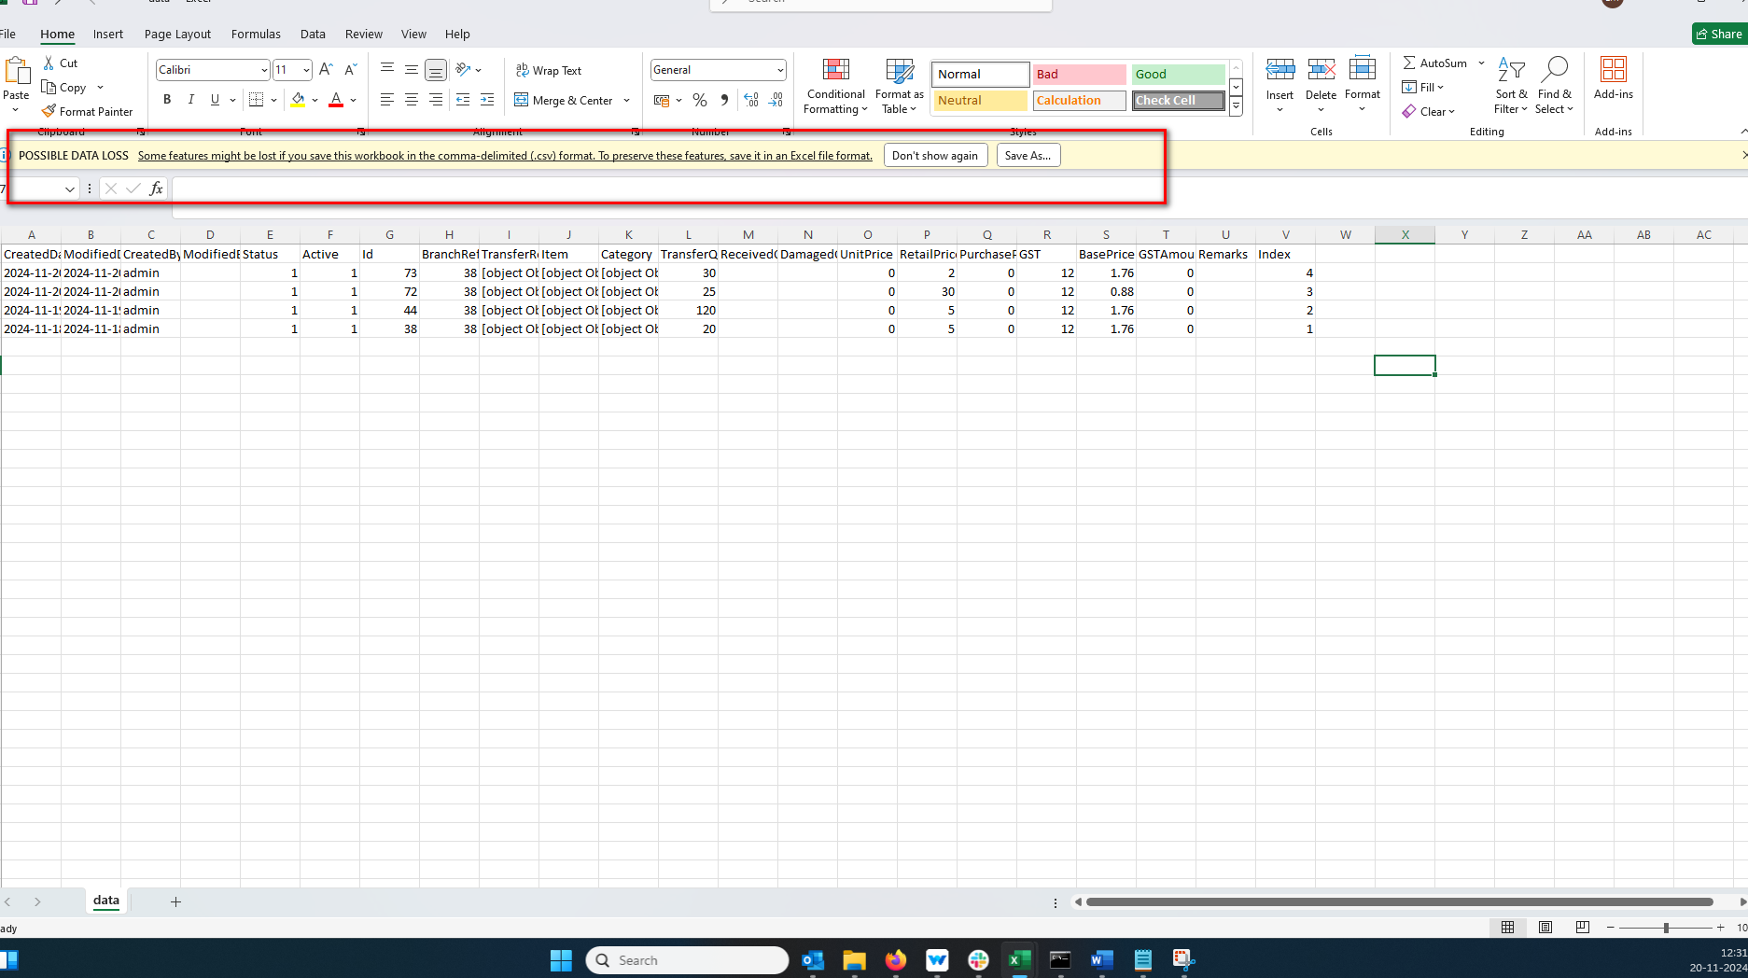 //
28. Mismatch Sheet name display in all downloaded document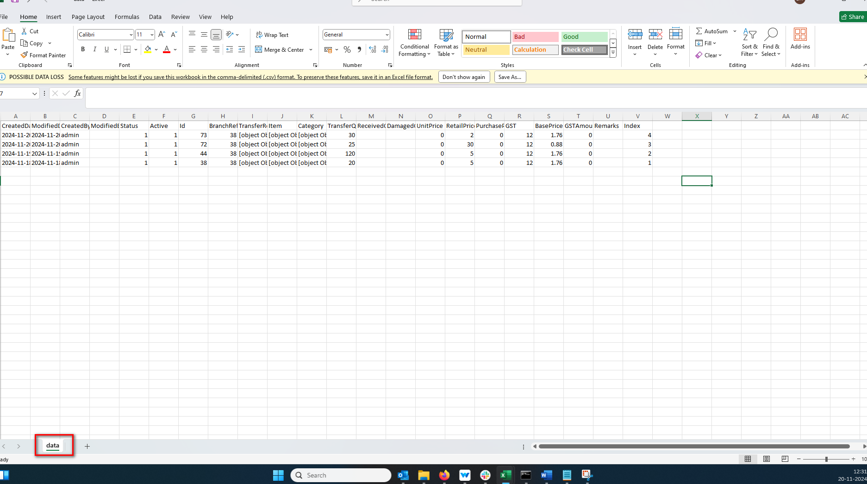//
29. The column header does not appear like the ad header column in CSV file 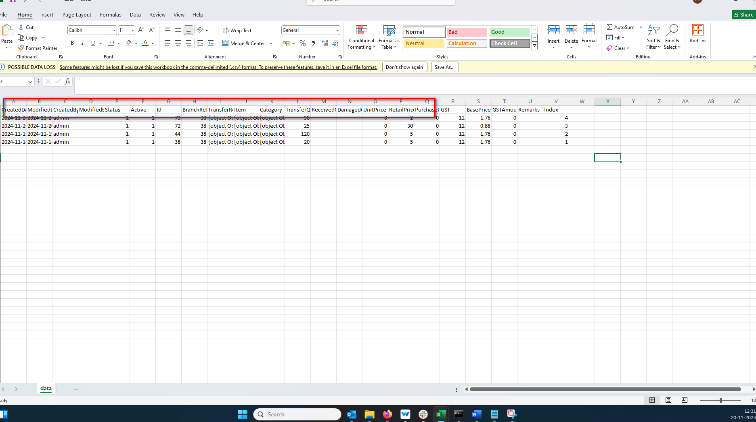//
30. The CSV download option displays an incorrect icon 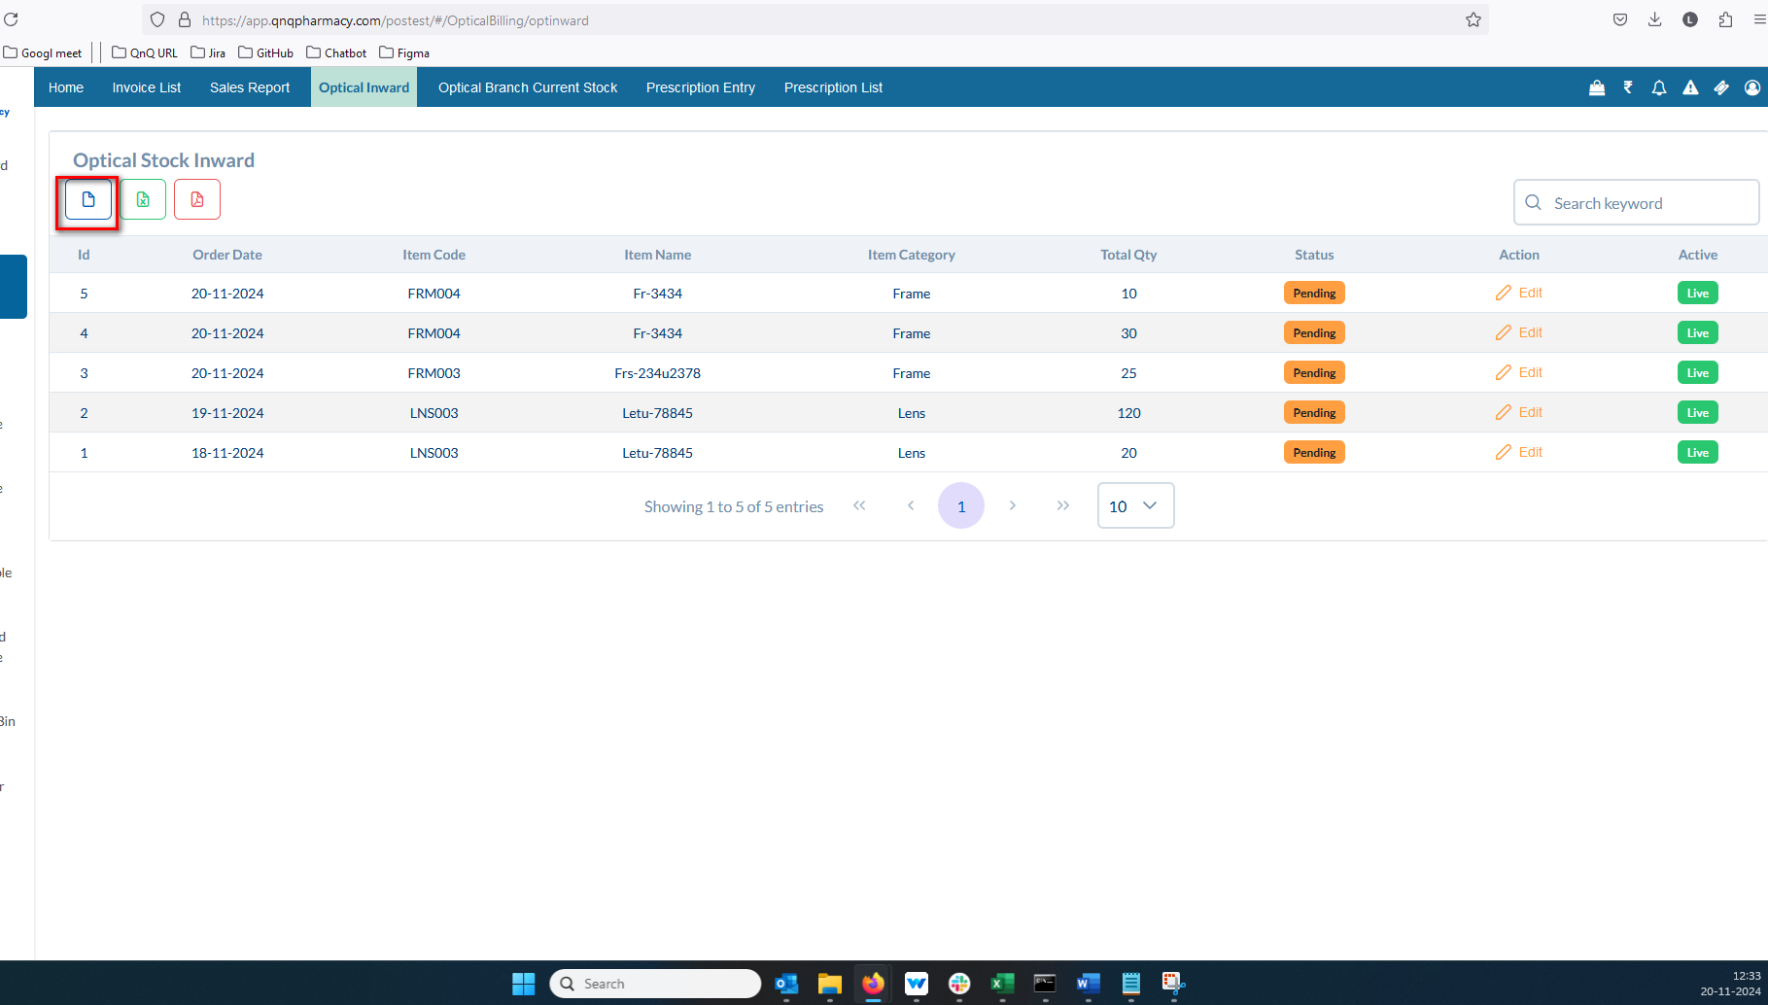 //
31. Success message display mismatch content 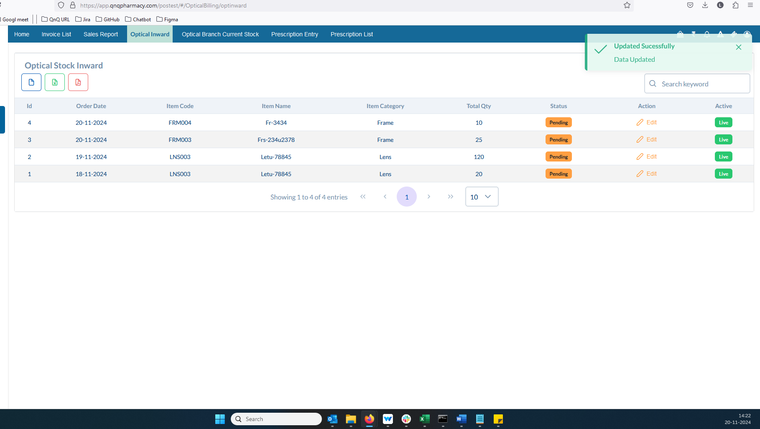 //
32. Verified records not display  //
33. Button name not display as Verify//